Advanced-tooling assignment – class 3 -instructions -VAGRANT

We are gonna take tools we build last time and build a development environment

Download the markdown.(template .md) That should be in our local repository under 521 folder , create a directory tooling assignment-advanced, create images folderjust like how we did last time. (for ref see the previous tooling asignm part 2)

The other link is instructions and what required.

let’s go through the instructions link:

**THEORY : SOME IMP POINTS**

virtual machines:

virtualization: we use a piece of software, that is VirtualBox for x86 (windows) parallels for m1 or apple silicon. This will help us lie to the computer.

it will create hypervisor ~ translator b/w your computer and virtual machines, it slows down you computer a lil bit but,

it helps you to install many os’s on your computer without having to have multiple computers

for instance: I wanted to have 5 os’s means 5 linux versions. So I can build with virtualization instead of going to amazon for buying desktops. (this is mine)

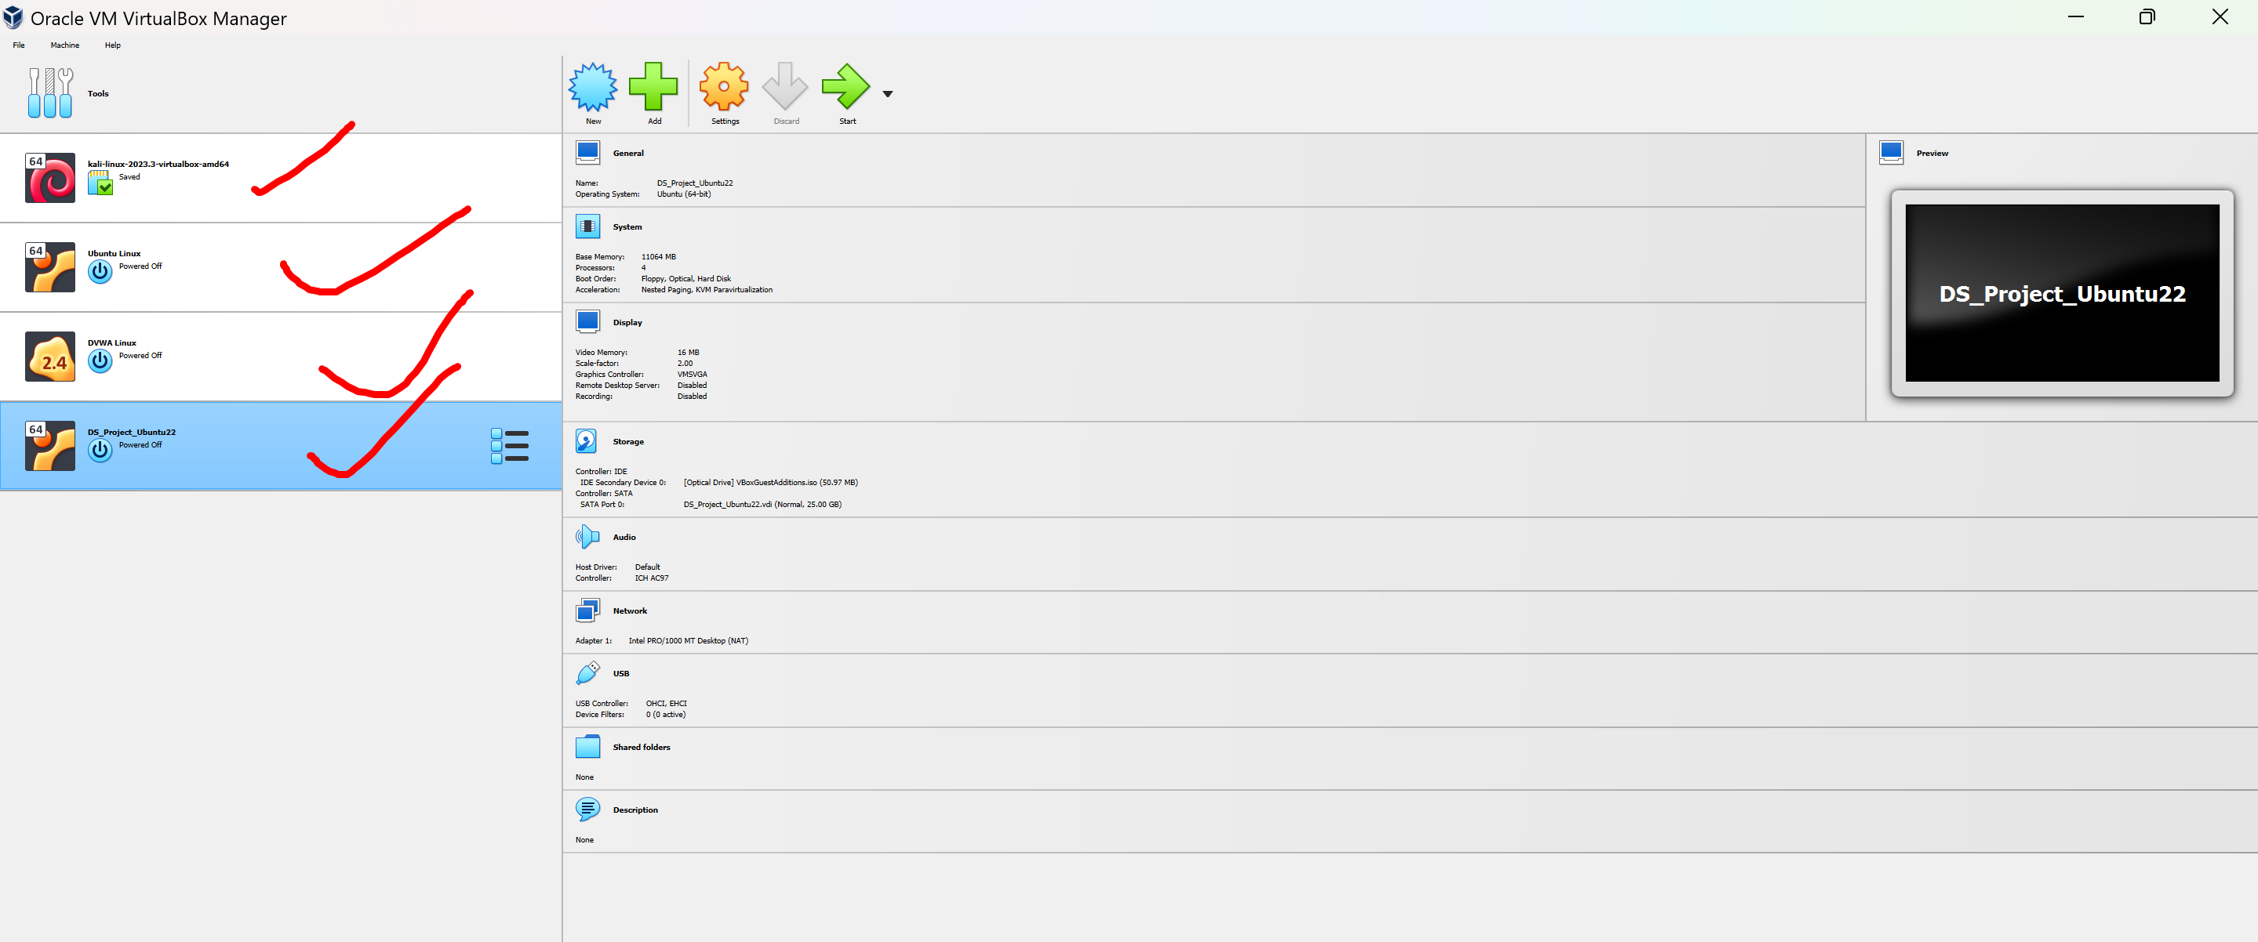

here we got 4 desktops and servers. Why iam installing various software’s on linux that wont work well with windows.

So HYPERVISOR is virtualization software (virtual box or parallels) . that creates and runs virtual machines.

So, we are going to set up our own development envi especially in virtual machines.

We don’t have to cross pollinate. Bcoz diff os will have diff paths like for windows and mac

Also, you are never going to run production on mac or on windows. Its going to be on Linux. And Linux is cheap and that’s going to run everything on the enterprise.

So how do we do that?

We have this tool installed: virtual box for windows……. parallels for mac.

So, we installed other tool called **‘vagrant’** from a company called hashicorp.

**How does VAGRANT interact with virtual box?**

Through vagrant commands. These will start vm’s without any screens or gui.

He is in documents directory **( cd Documents**)

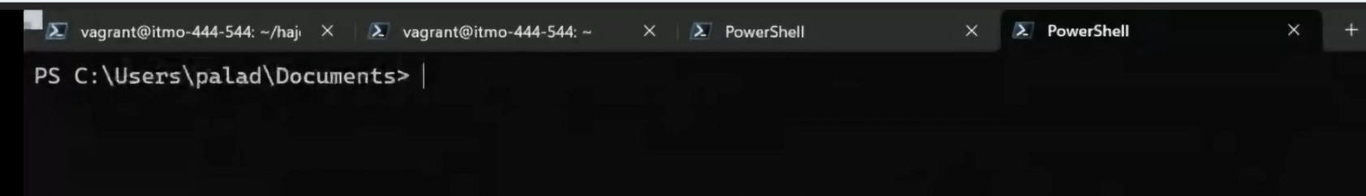

Just for us he showed by creating a test directory in documents directory and went to test directory

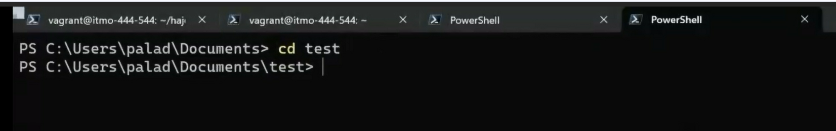

Then he went to jammy vm by the command cd path jammy (becoz he created jammy or folder or directory)

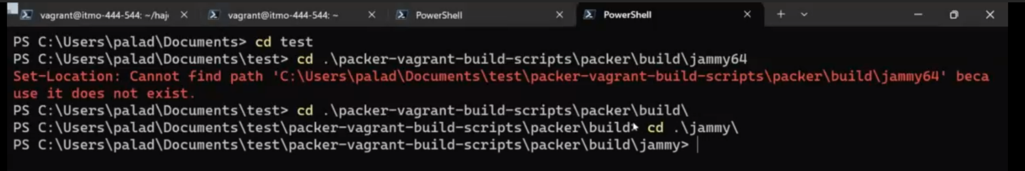

No vm are open now, he want to start vm now so he need to get connected and so that he need to install some tools. So vagrant up

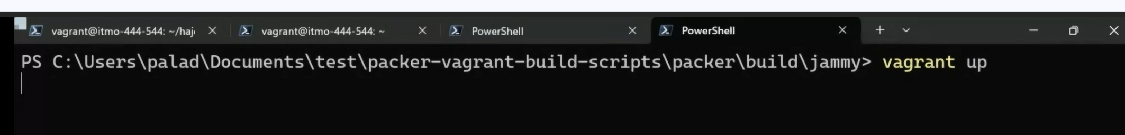

**vagrant up** (hit enter) it will reboot for a while you will see after a lot of lines “booting vm”

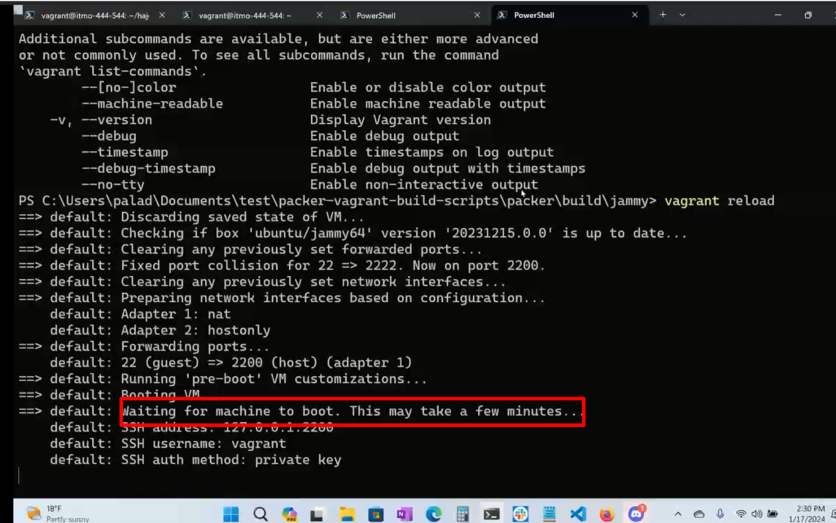

Vagrant tool is going to abstract these commands into the equivalent command line commands to start vm’s without any screens (its going to do quietly) so the command to start the vm is vagrant up

He did **vagrant restart**

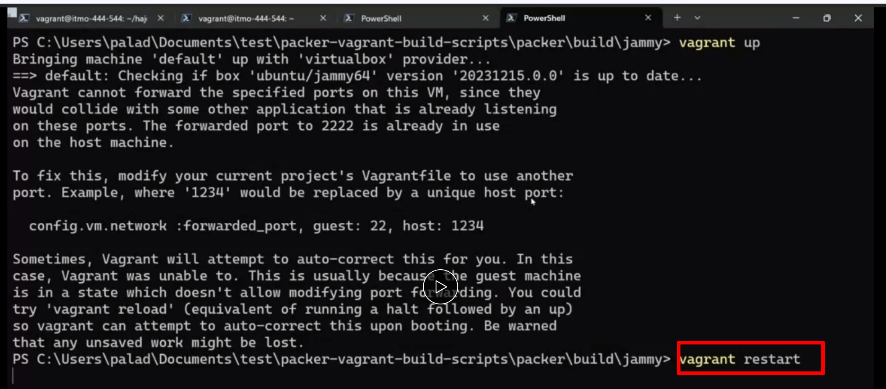

Then he did vagrant reload

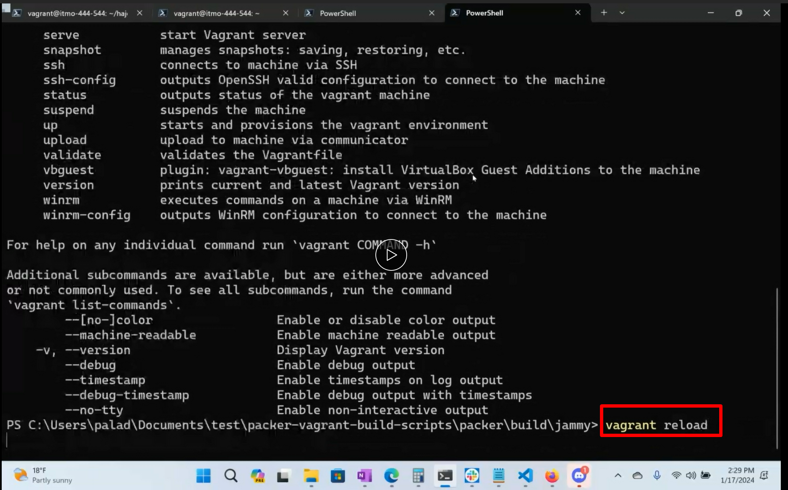

Here the vm is starting . where is it ?no big window is opening , just by this. If we observe its gonna make its own authentication with its own ssh private key (no pd, no username). We just connect to our development environment. (that’s what we want to do. We wanna develop,,,,, we don’t want to answer timezone questions, we are just like give me the system.

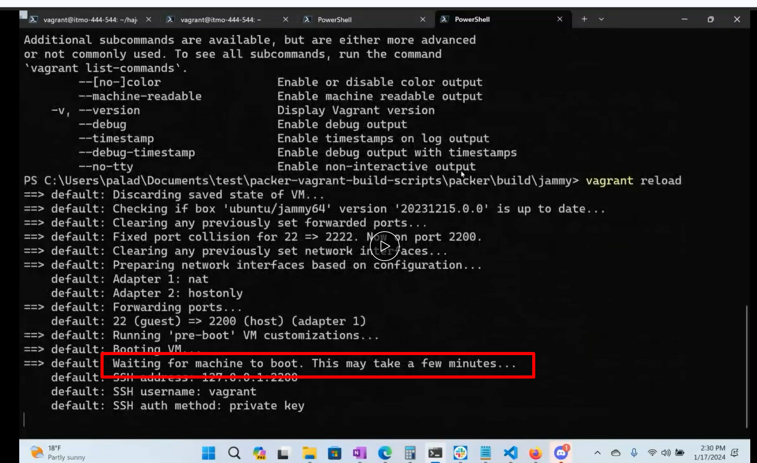

Troubleshooting : if its not starting don’t power off the vm in virtubal box by gui like this but it should run in background (like prof did here) if we open the oracle virtual box we can see the jammy running but we cannot see in terminal PowerShell 7

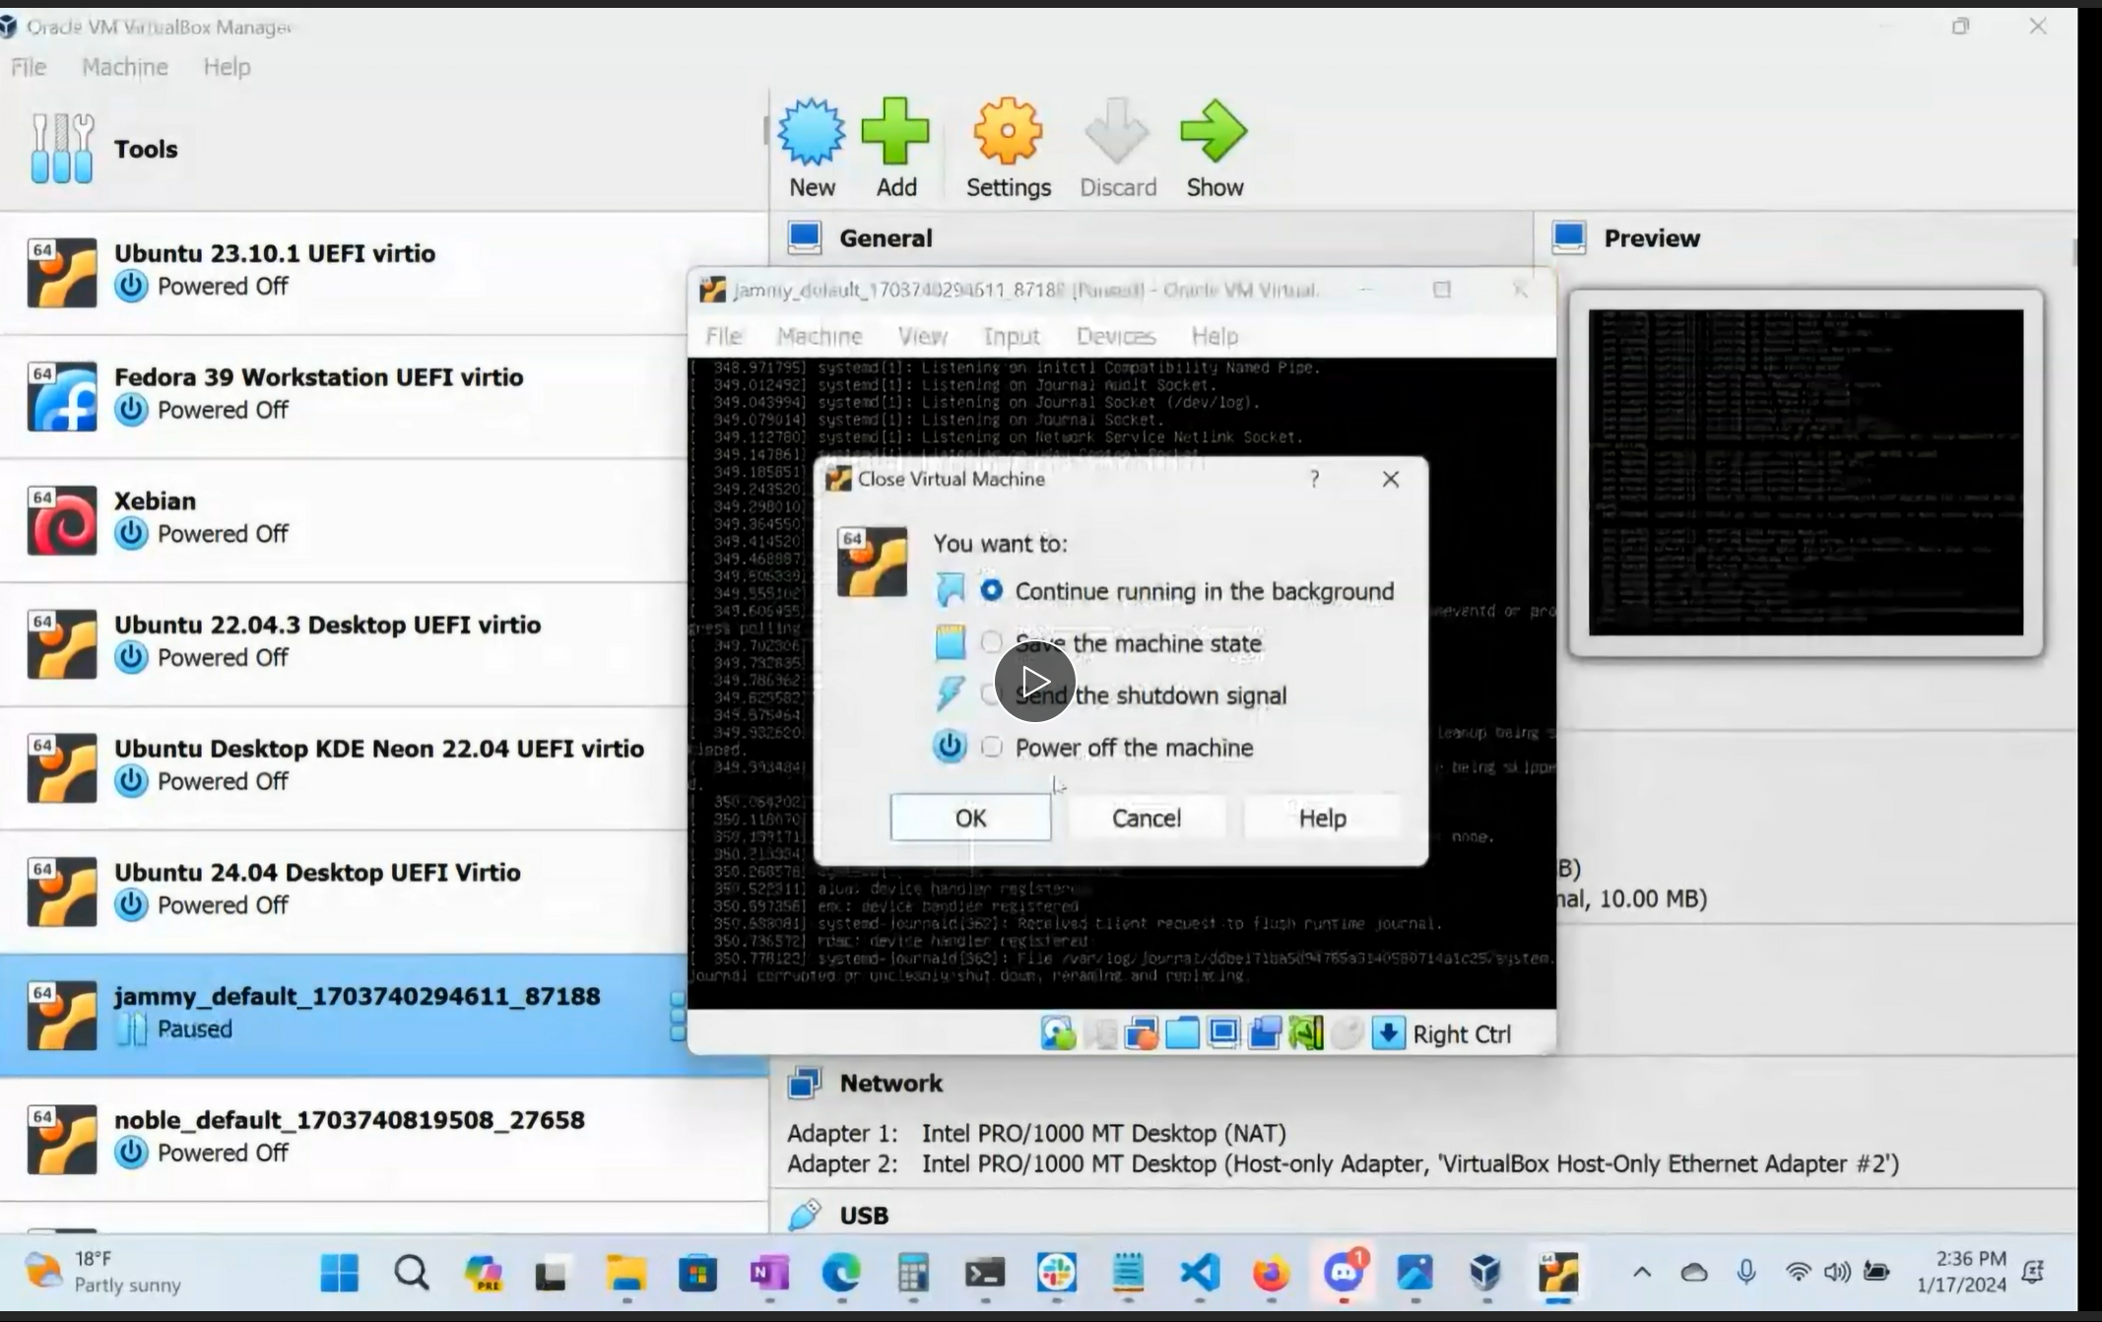

Vagrant is a tool for building and managing machine environments in a single workflow so we dot have to jump into the virtual box and then jump into the vm’s (GUI). We just have a single flow from the command line. That’s why we had to install PowerShell 7, vagrant had to install, all these things in our previous tooling assign 1

Is easy to work and focus on automation. Also lowers the development set up time.

Why vagrant? We are not dealing with VirtualBox or parallels, but Vagrant is an abstraction layer that encompasses both. It’s a logic that can run on windows and m1 mac that can be remotely accessible.

Vagrant work on both. It speaks both of those languages.

Vagrant increases portability, distribute scripts, to other classes, colleagues, (ability to transfer scripts wherever we want) if other are using diff os’s we cant say no you cant use that laptop or something like that, we now have an abstraction layer. Maximize productivity.

Vagrant standardizes what everybody is working on. We can all have exact same machines. No differences, no windows 10, 11 etc., we don’t have this patch and that patch, nothings stops.

We can make sure it works on each of these machines and bcoz these env’s are virtual and we have all our code in version control, we can throw the virtual thing away if something happens, quickly rebuild it and clone our code again and start again. That’s the trouble shooting benefit for professor. Obviously for us.

Finally, its an abstraction layer that sits on top of virtualization platform like hyper v or vm ware and streamlines the work flow

Then he did **vagrant ssh** to remotely connect

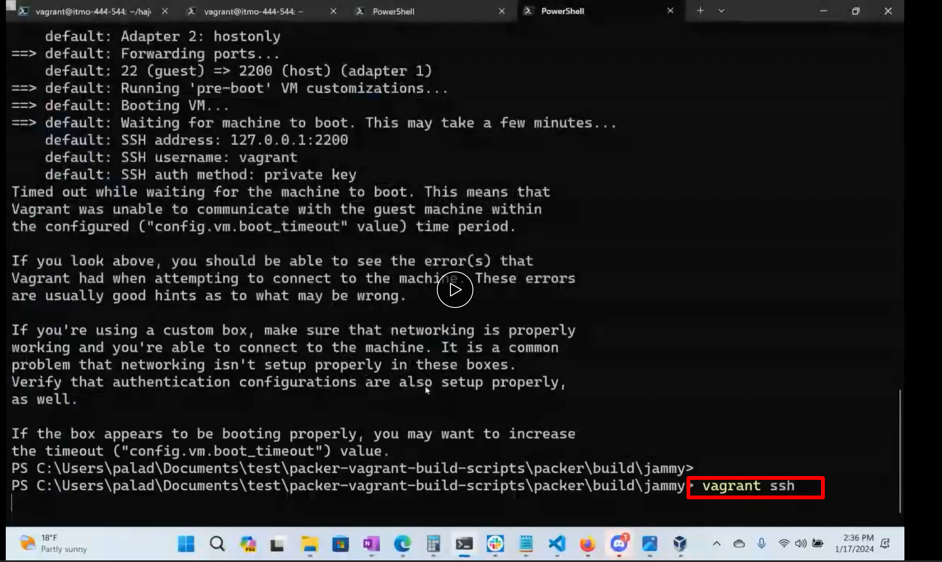

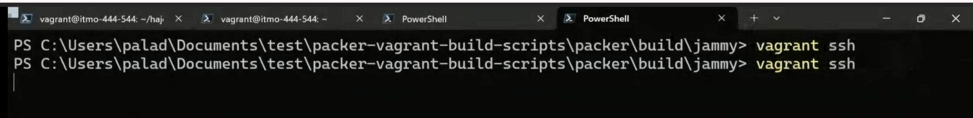

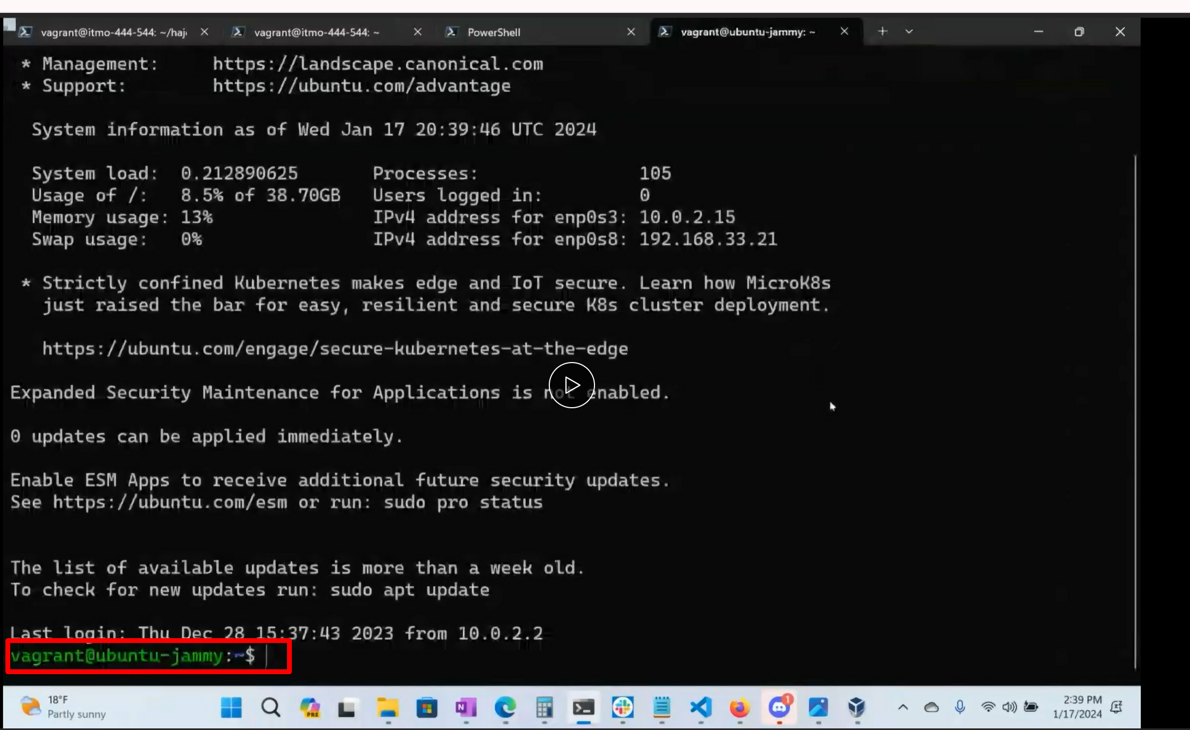

Vagrant has 2 concepts: (it don’t create anything by itself , it only interacts with virtual box in windows or parallels in mac)

. box file: which is the actual hard drive contained in a compressed file and lil bit of meta data

Vagrant file (V) which instructs all the vagrant commands you execute, which vm to run them on.

**********************************

So lets go to commands : the actual assignment starts here:

Lets Run **vagrant --version** to show the version of vagrant and to make sure whether it is installed or not from the previous tooling assignment: go to terminal powershell 7, go to Documents directory by command

**cd Documents** You are in documents directory

**vagrant --version**

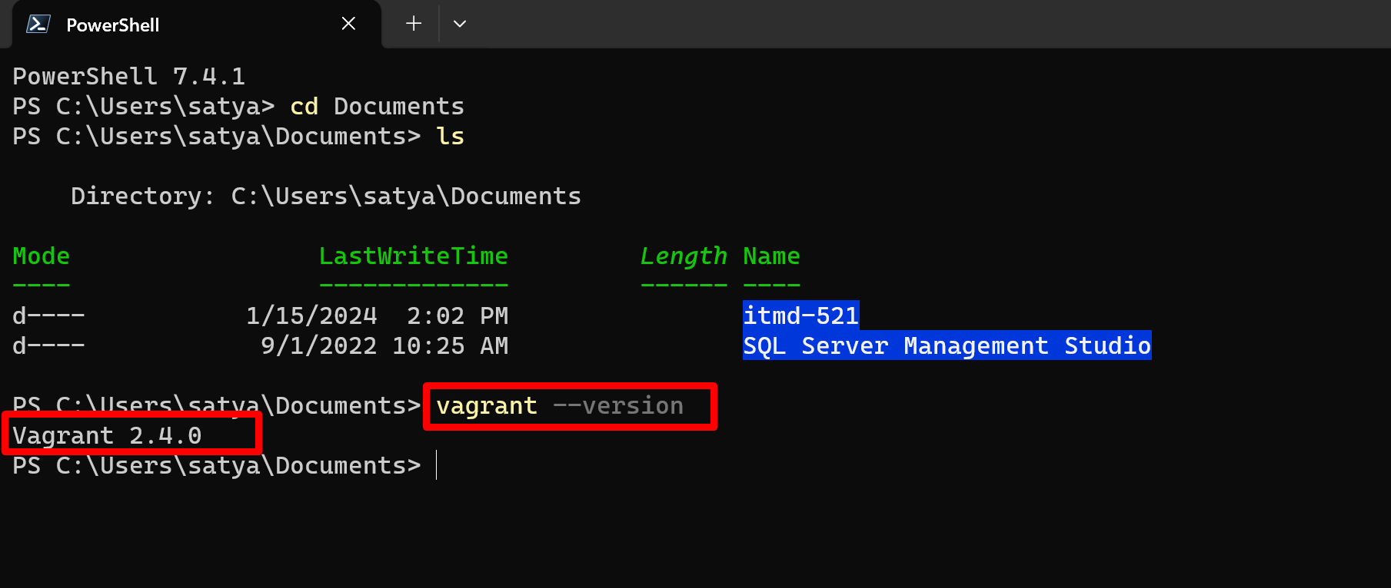

Les go ahead and get some virtual machines from the vagrant cloud.

One thing is where you store the code is our wish, no need to be in local repository (tbh prof advised not to put there)

Prof suggested put in in **documents.**

**\*\*\*\*\*\*\*\*\*\*\*\*\*\*\*\*\*\*\*\*\*\*\*\*\*\*\*\*\*START\*\*\*\*\*\*\*\*\*\*\*\*\*\*\*\*\*\*\*\*\*\*\*\*\*\*\*\***

Let’s go ahead and make a directory now. For (virtual machines). ~~~~~ we already created itmd-521 in the document’s directory in our previous tooling assignment. So, we can create something like

**itmdvm-521**

Note: whatever directory you make in documents. Don’t make any spaces instead use dashes.

Open terminal (as user not as administrator, so no right click and run as administrator just double click on terminal). So, in terminal PowerShell 7..be in documents directory

create a directory Itmdvm-521 (for virtual machines.) **in documents directory**

**mkdir itmdvm-521 ; cd itmdvm-521**

(you can run both at a time with semicolon in the middle or you can run separately with no semi colon like professor did

and make 2 directories in itmdvm-521

**mkdir jammy64 ; cd jammy64 ; vagrant init ubuntu/jammy64 ; ls**

**mkdir almalinux9 ; cd almalinux9 ; vagrant init almalinux/9 ; ls**

(2 vm’s here is ubuntu in jammy 64 directory and almalinux is redhat

(you can do all the command at once or separate)

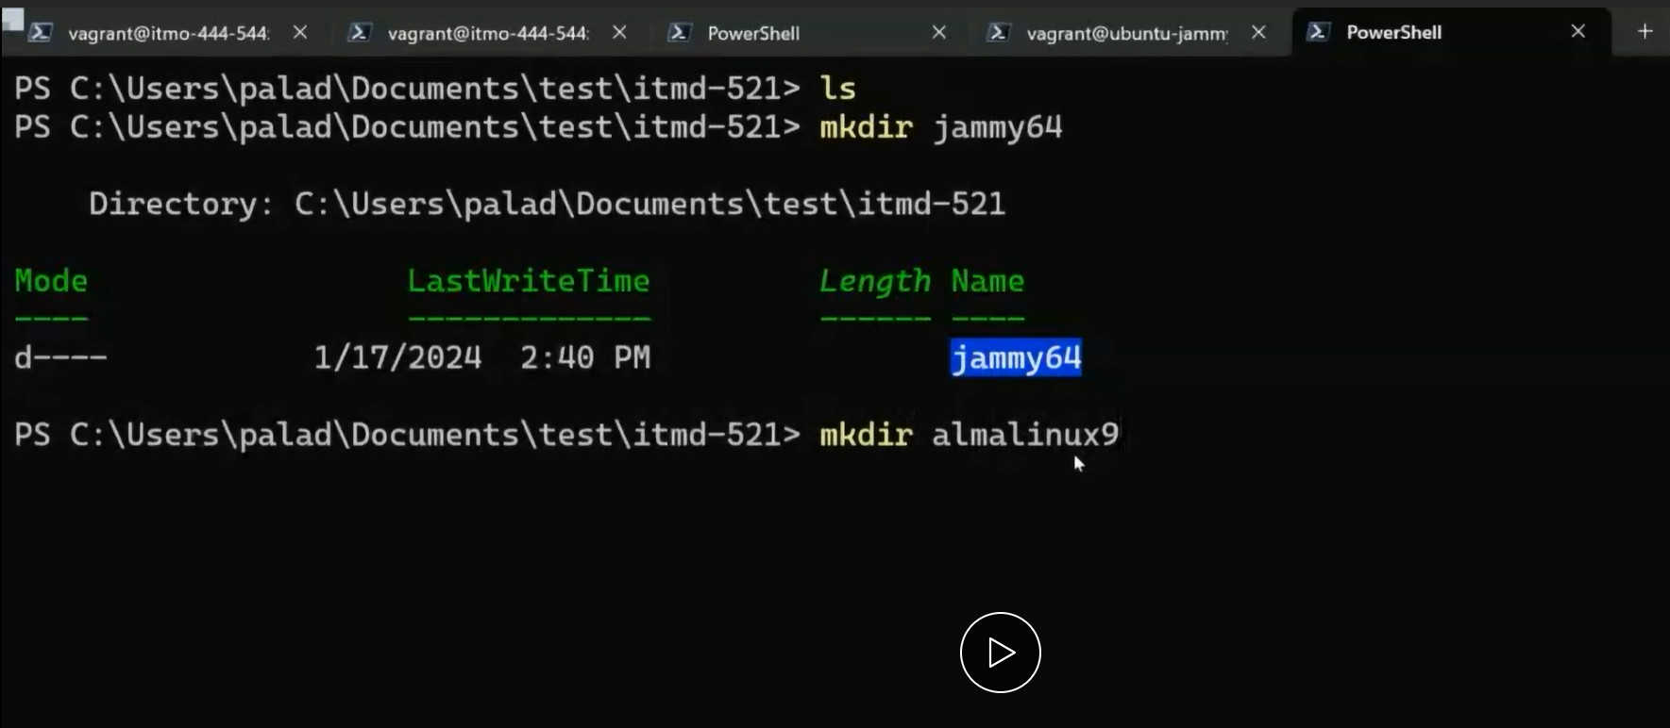 (this is professor’s screenshot)

what these 2 commands doing? Making jammy64 & almalinux8 directories in itmdvm-521 and initializing these virtual machines in these 2 directories by that vagarnat init command

in our intel windows we need to write that ubuntu jammy64 , it’s a shortcut to go to the store and get that virtual machine already installed. If you type the name it won’t be able to find the match and it will say not found.

The vagrant Init command ..im gonna go into the vagrant cloud and retrieve this virtual machine(ubuntu) from them

Hit enter after that vagrant init, its gonna take some time and say a VAGRANT FILE has generated. Type ls to see

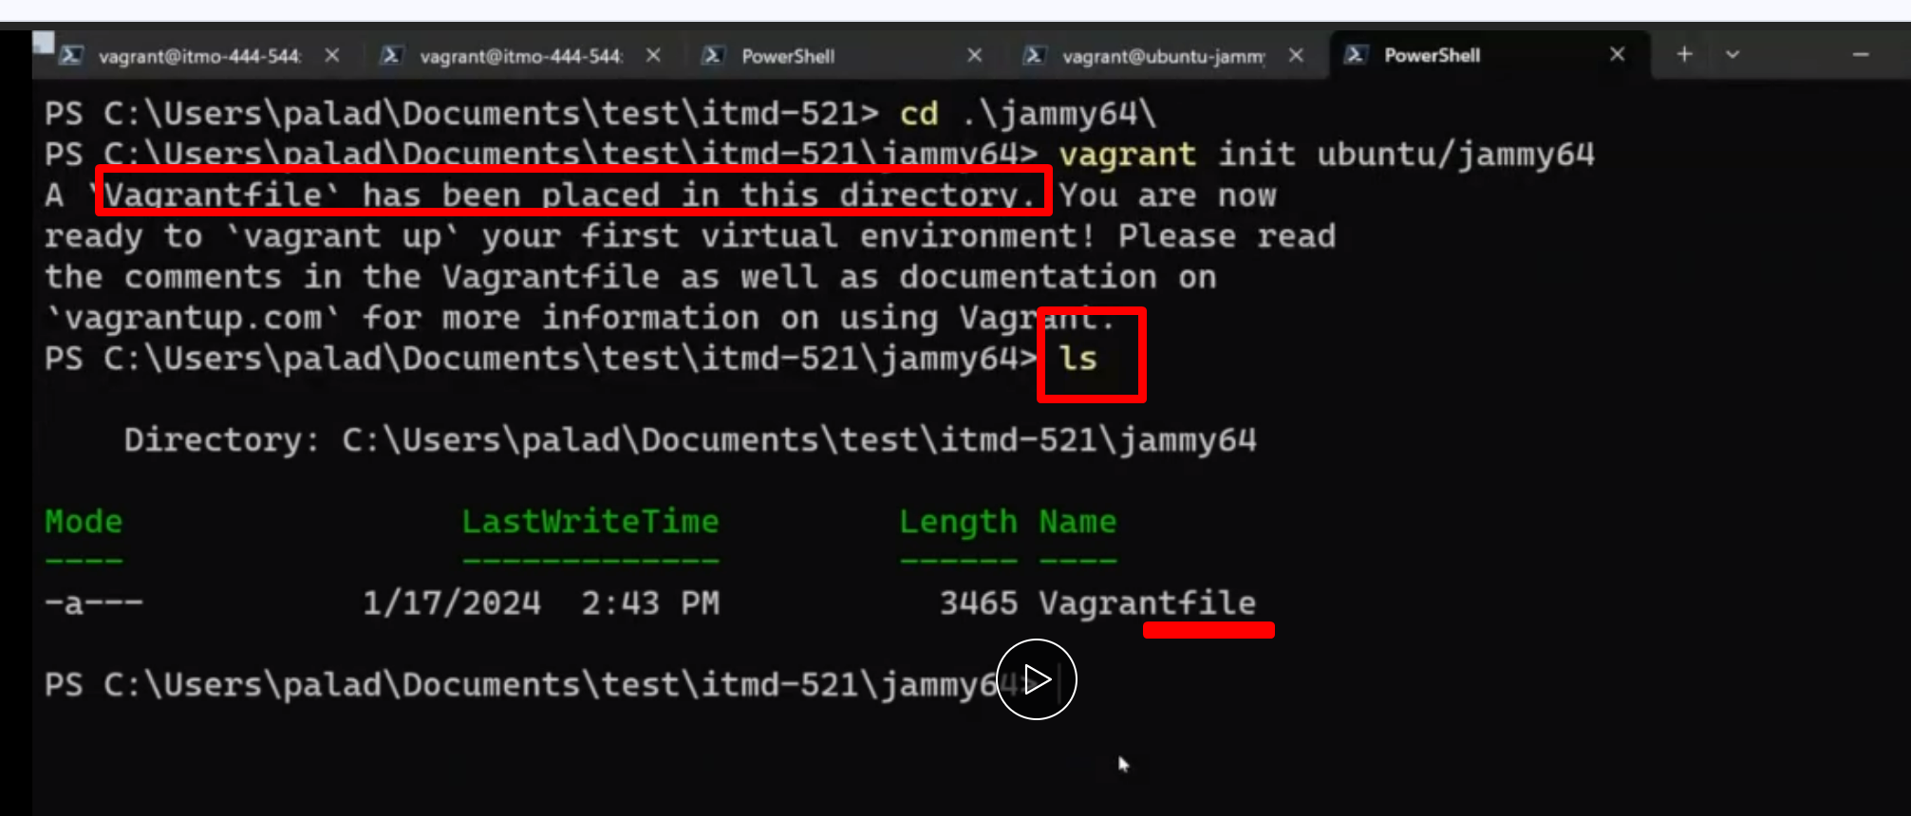

So in these 2 directories that initi command will create 2 VAGRANT FILES

This vagrant file tuns all the executable reads and turns it into the virtualization commands(parelles, hyperv, x86vm) and launch virtual machine.

If we want to read vagrant files values you can do

**code Vagrantfile** opens the vagrantfile in vs code (text editor)

**atom Vagrantfile** opens the vagrantfile in atom (text editor)

**vim Vagrantfile** opens the vagrantfile in vim (text editor) you can install vim using chocolatey

but we will do

**code Vagrantfile -** hit enter, opens the file atomat in vs code

observe the file , a lot of content and code here, the most imp is

**line 15 ‘config.vm.box = ubuntu/jammy64** this is how you associate the config file with virt mach

bcoz every virtual machine needs a config file. So these 2 directories will have 2 vagrant files and 2 vagrant files will have 2 config files.

So do these steps for the 2 above directories, run those 2 commands for both directories, initialize the vm’s and create vagrant files.

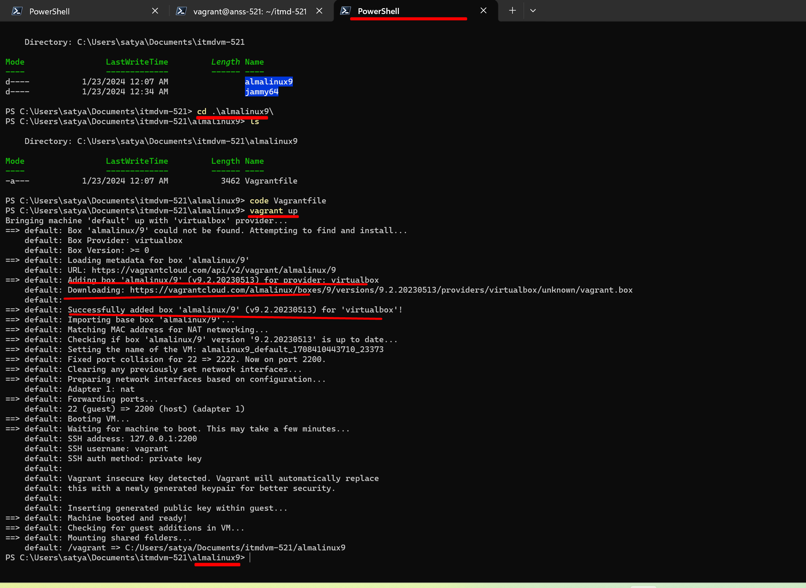

LETS START VAGRANT BOX:

Go to jammy64 or alamlinux directory with the command

**cd jammy64**

**cd alamlinux**

**we will do in jammy64** we will go into jammy64 from alamalinux with this command.

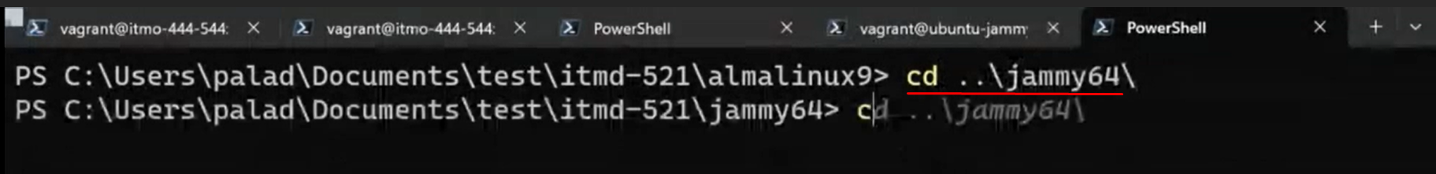

type **vagrant up** hit enter its starts the vm In gui (if it don’t start do vagrant halt)

(why did prof enter vagrant halt? For shutting down) these are some additional commands:

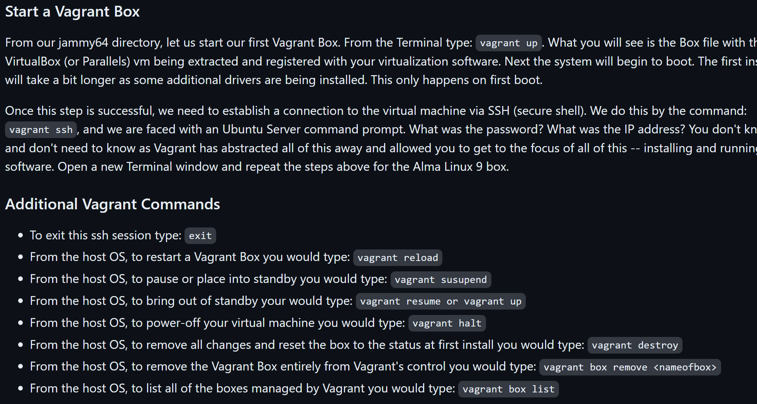

When you do vagrant up and if you see hanging up, go to virtual box and double click on the running

Machine and then it keeps loading. Then click close and keep the option continue running it background option.

This may or may not happen.

If we **get time out error msg** : video(sec 5) 38 min also do above also at the top of doc I mentioned.

Once you did vagrant up, your vmis running,

Then do **vagrant ssh** to connect to it we will get this output.

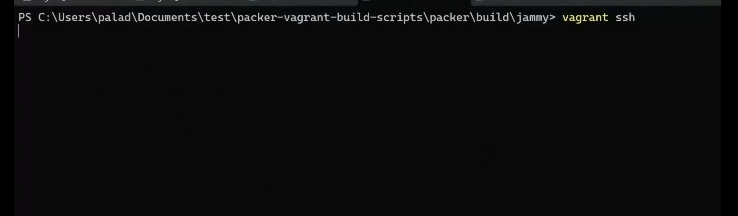

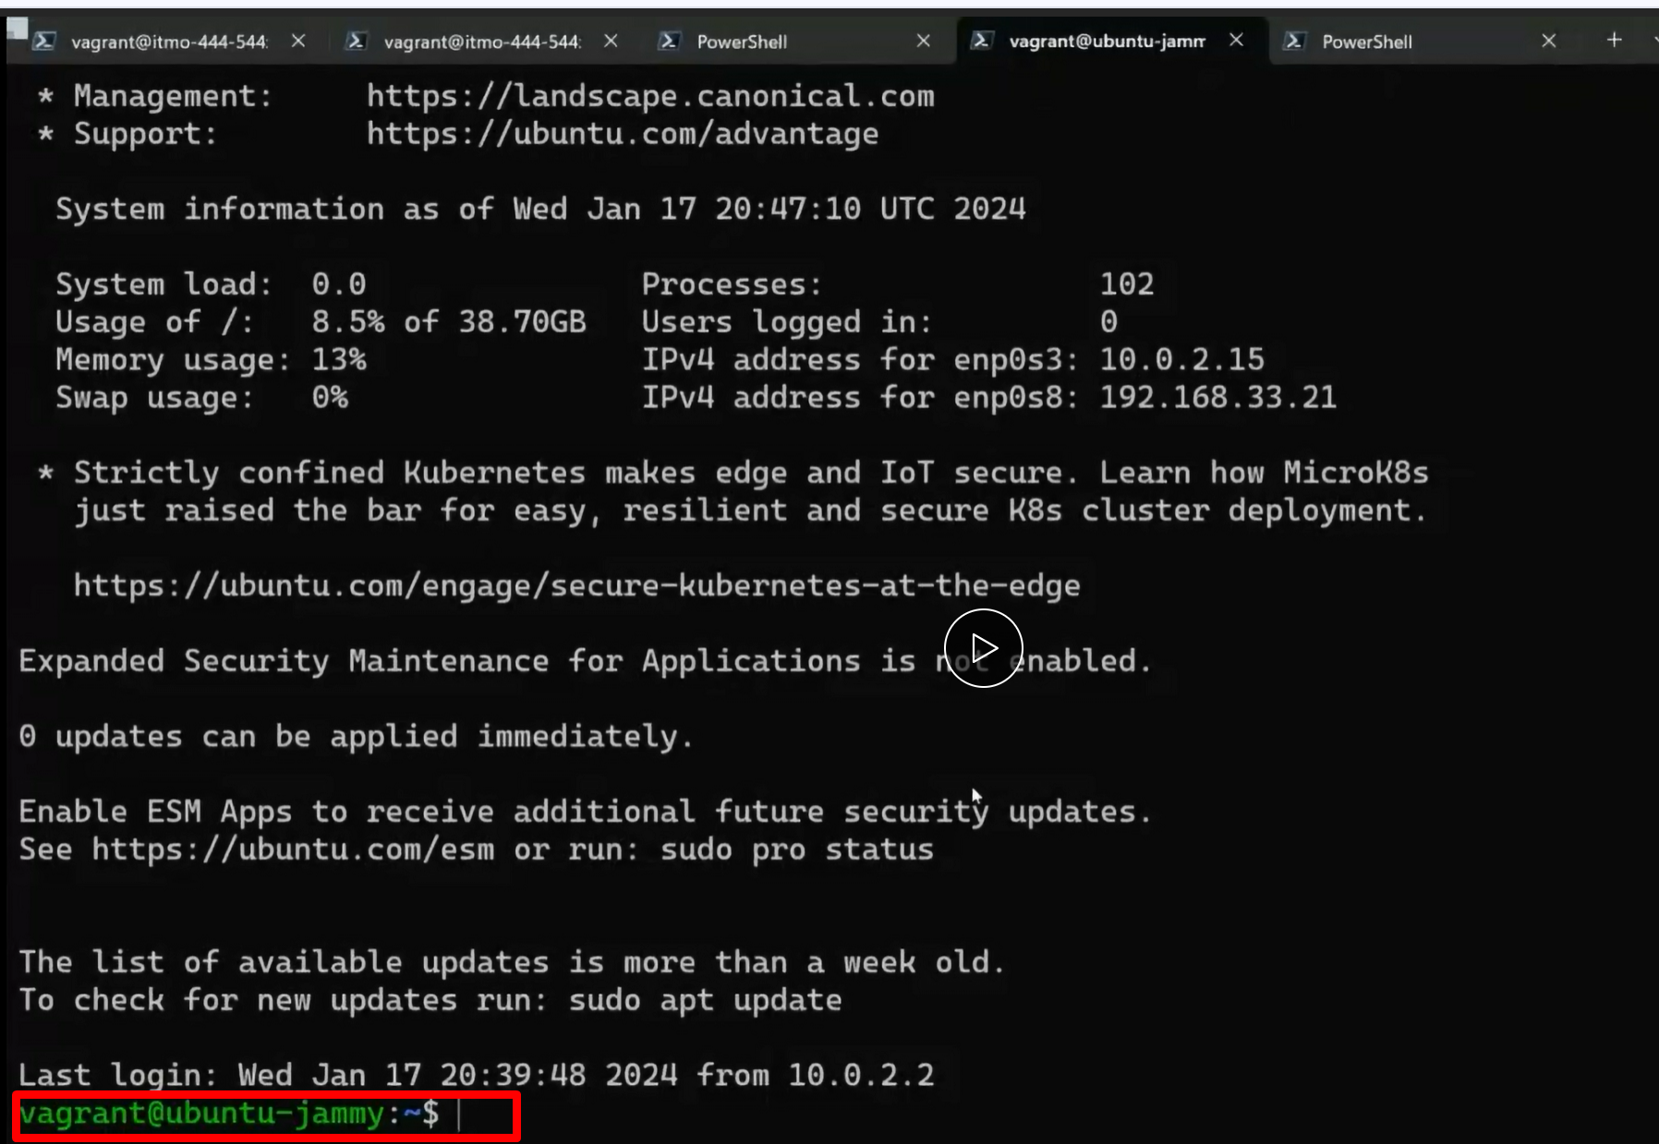

We got a development environment. We got a full linux operating system.

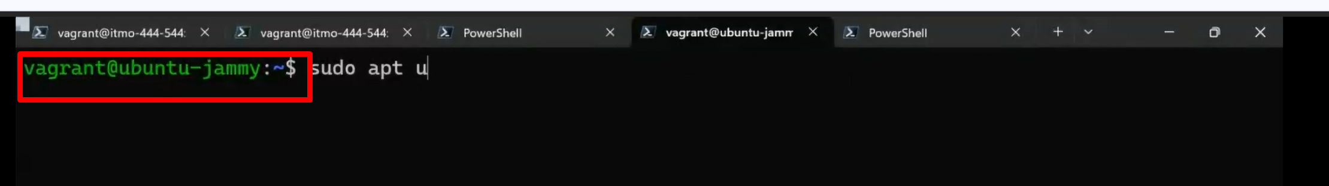

Type clear in this green directory vm to be clean

Type

**sudo apt update**

apt is a packet manager. This update is just to make sure we got the latest version of repositories.

Make sure you are looking at the latest repositories

(keep on hitting enter)

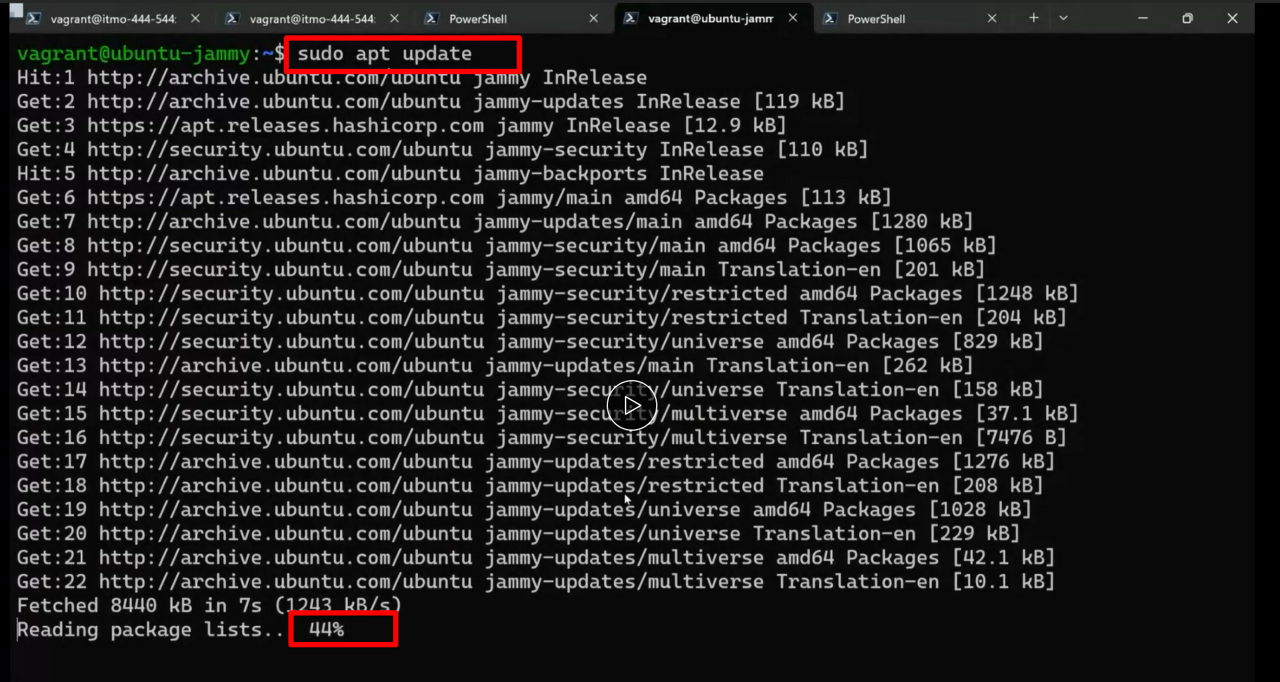

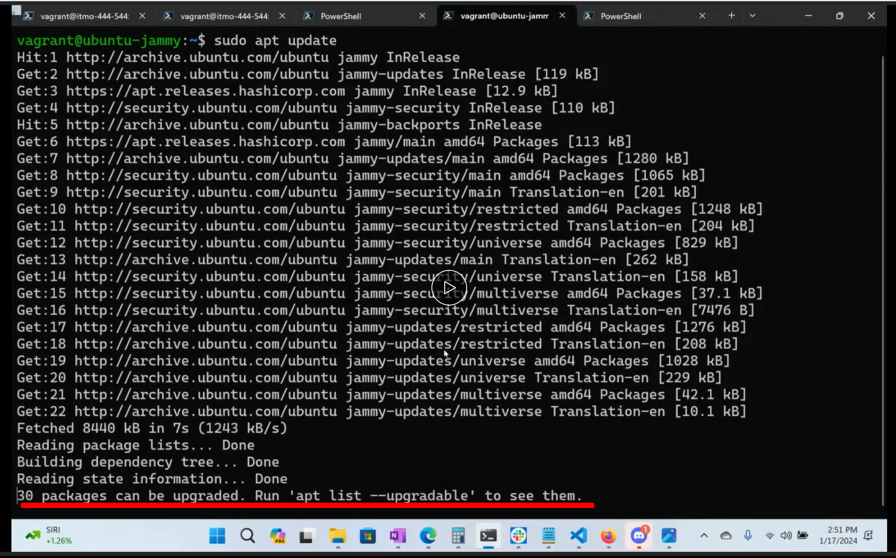

Ans then we can install all the software from here

We gotta install web browser, we gotta install java, we got install couple of things at the bottom of thr

instruction page

we can also do this. Looks familiar? Generating pub and private keys. (key pair). Add key pair to github

and create config file just like how we did in our prev tooling assignments in our windows

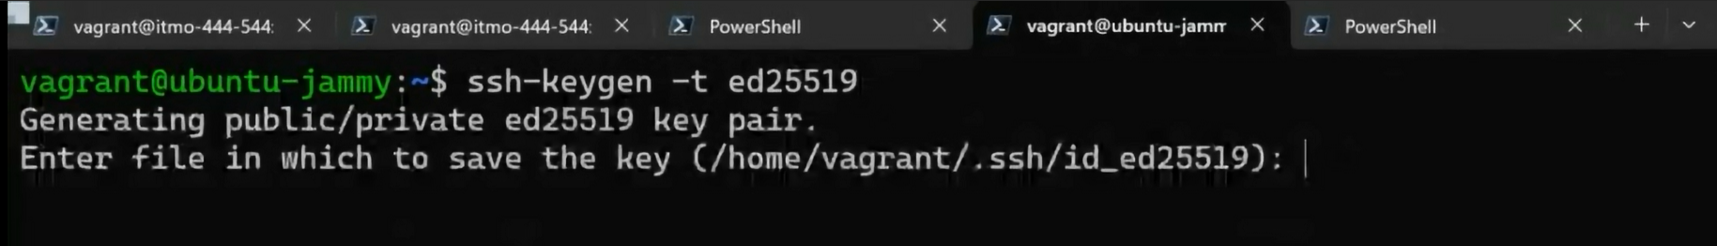

Aso we can clone the source code now into this vm machine. I can work on my windows/mac system

**push** it to github**, pull** to the vm, run , execute the code )no gui., no gmail.)

so **exit**… this will exit the ssh session but I wont shutdown the virtualmachine

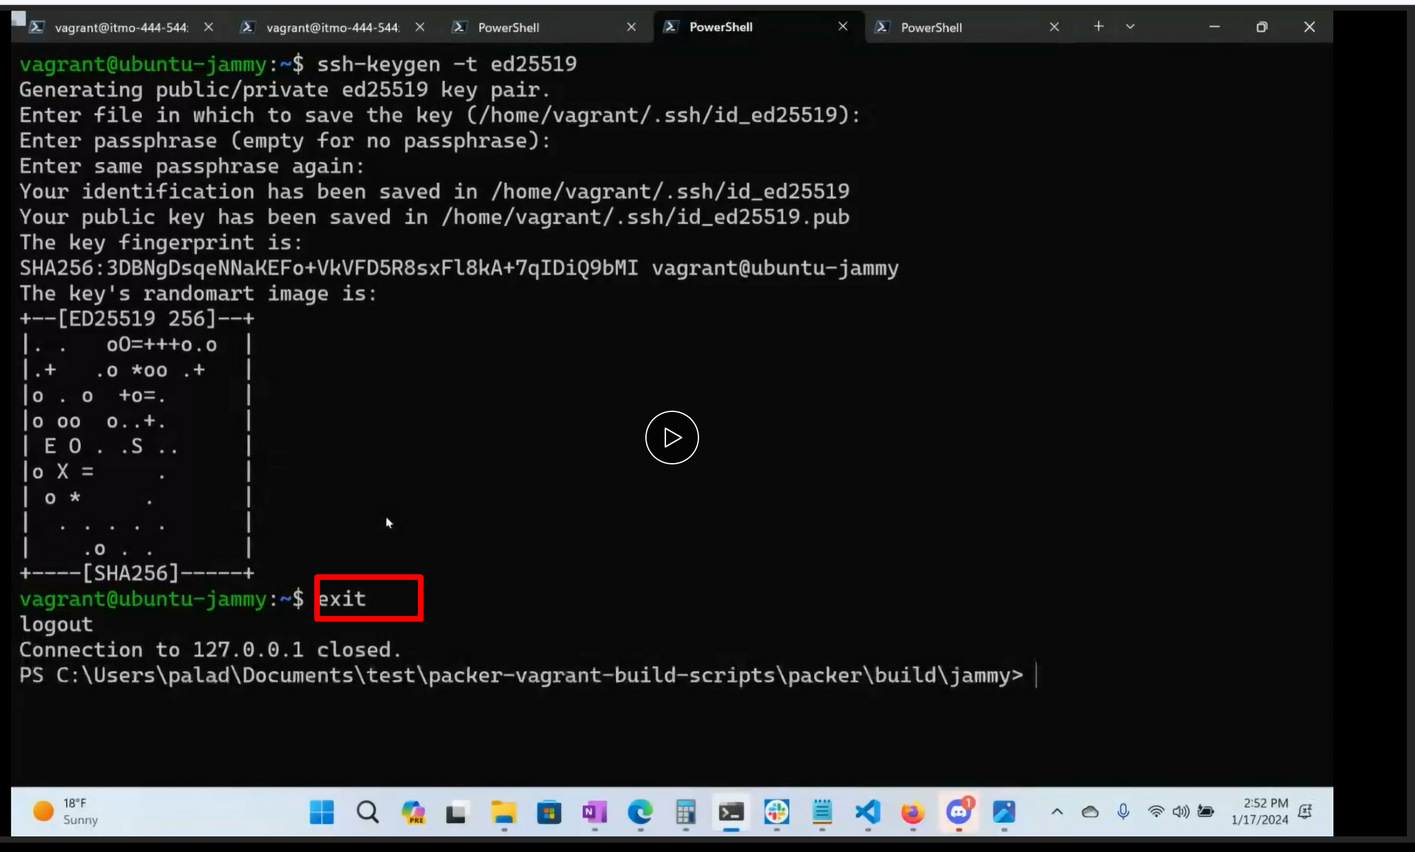

To shut down the vm :

**vagrant halt** - power it off

**vagrant suspend** - which will suspend

how to get it back

**vagrant resume / vagrant up**

how to reboot:

**vagrant reload**

what is **vagrant destroy**

lets say we installed this nginx webserver

**sudo apt install nginx**

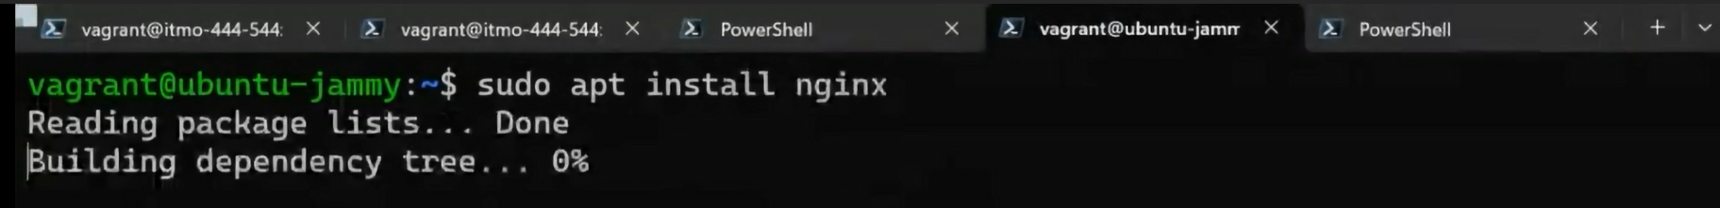

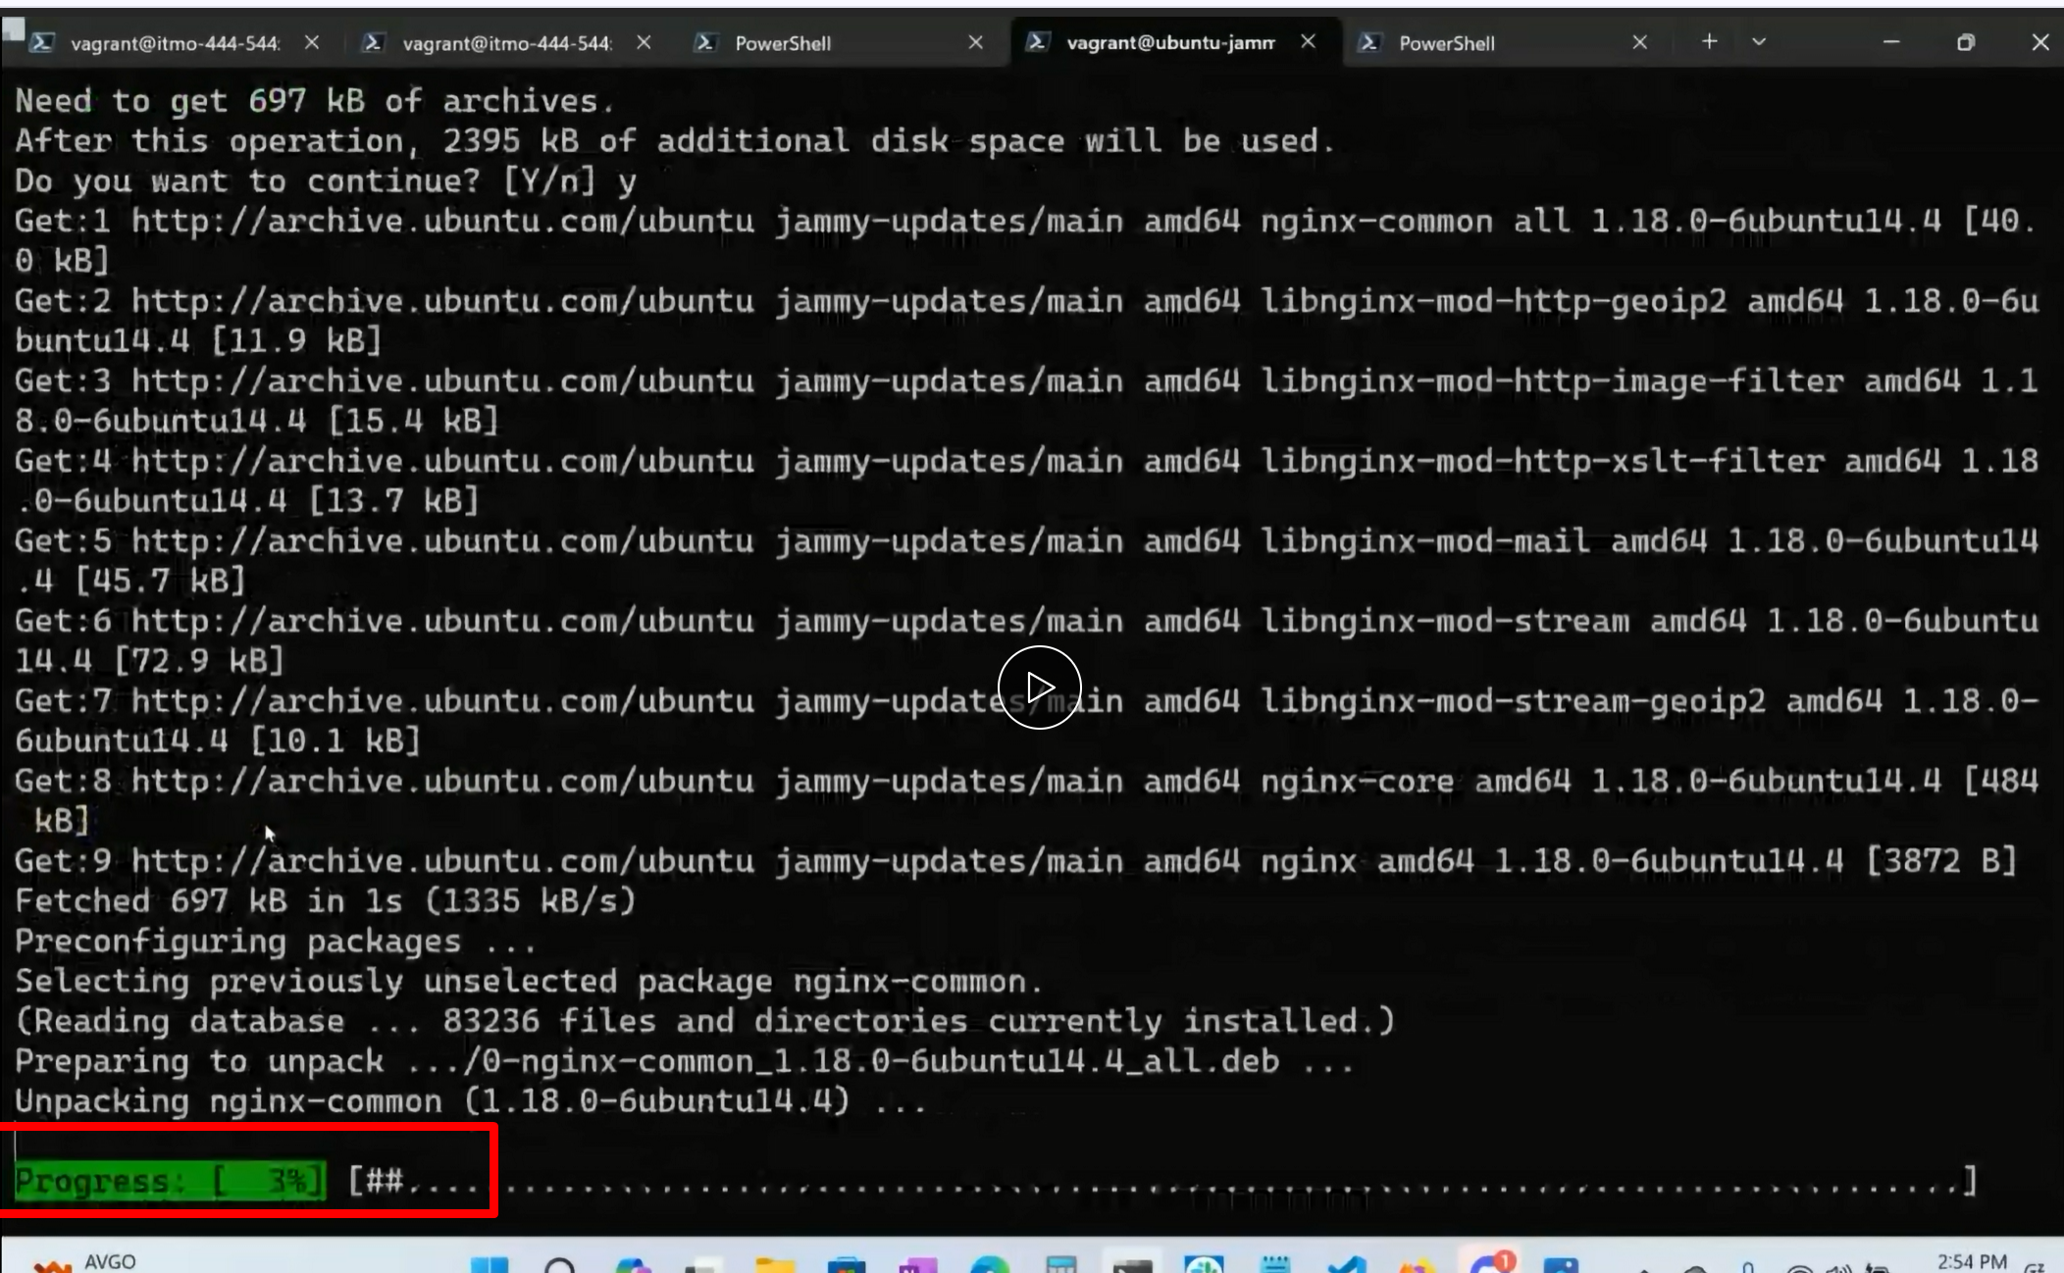

So it helps you to trouble shoot. if you got into trouble . I will tell vagarnt to destroy, it wont delete

anything.

If you install any fresh webserver,

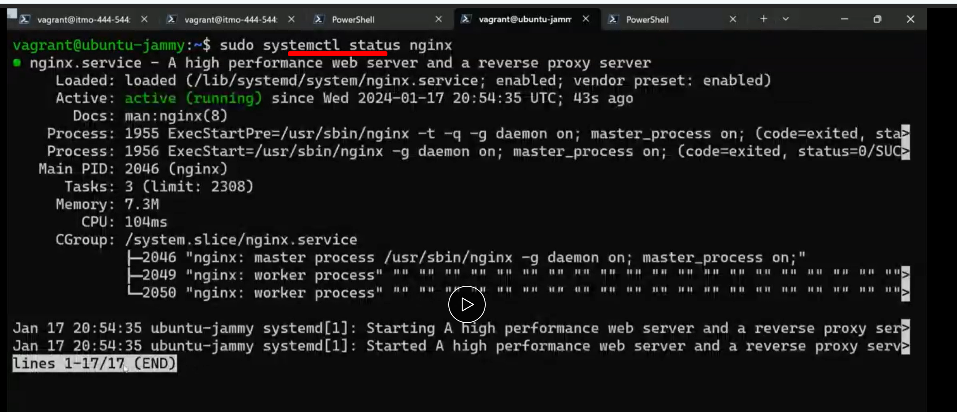

It stores all the changes in a sperate file, so if I want to back with a clean and fresh machine.

For instance:

If we want to create a homework answers and don’t want it blah blah…

So it basically clean and start again

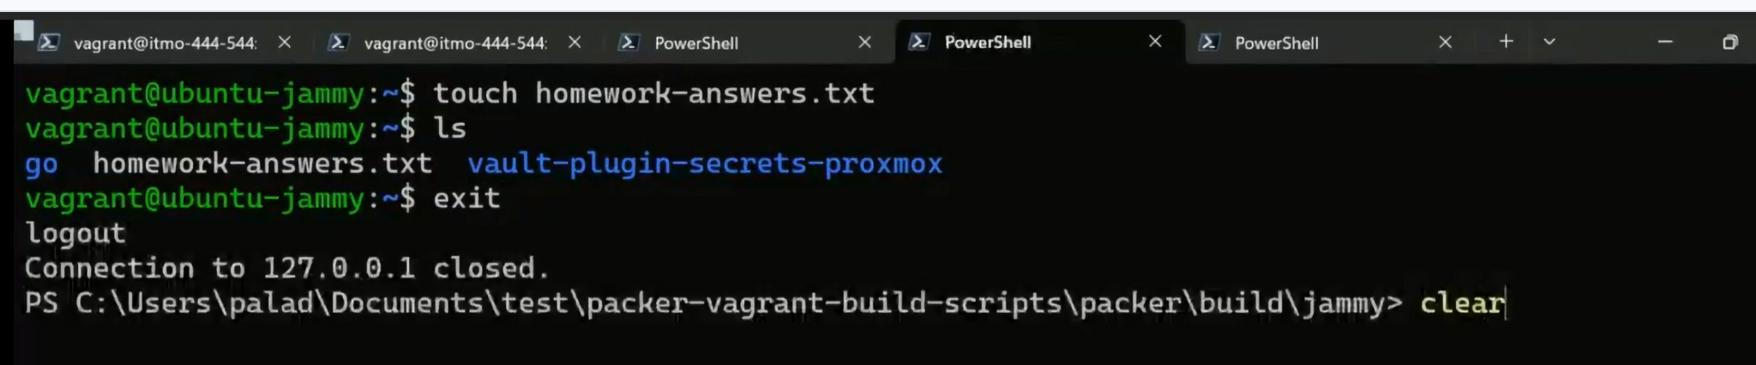

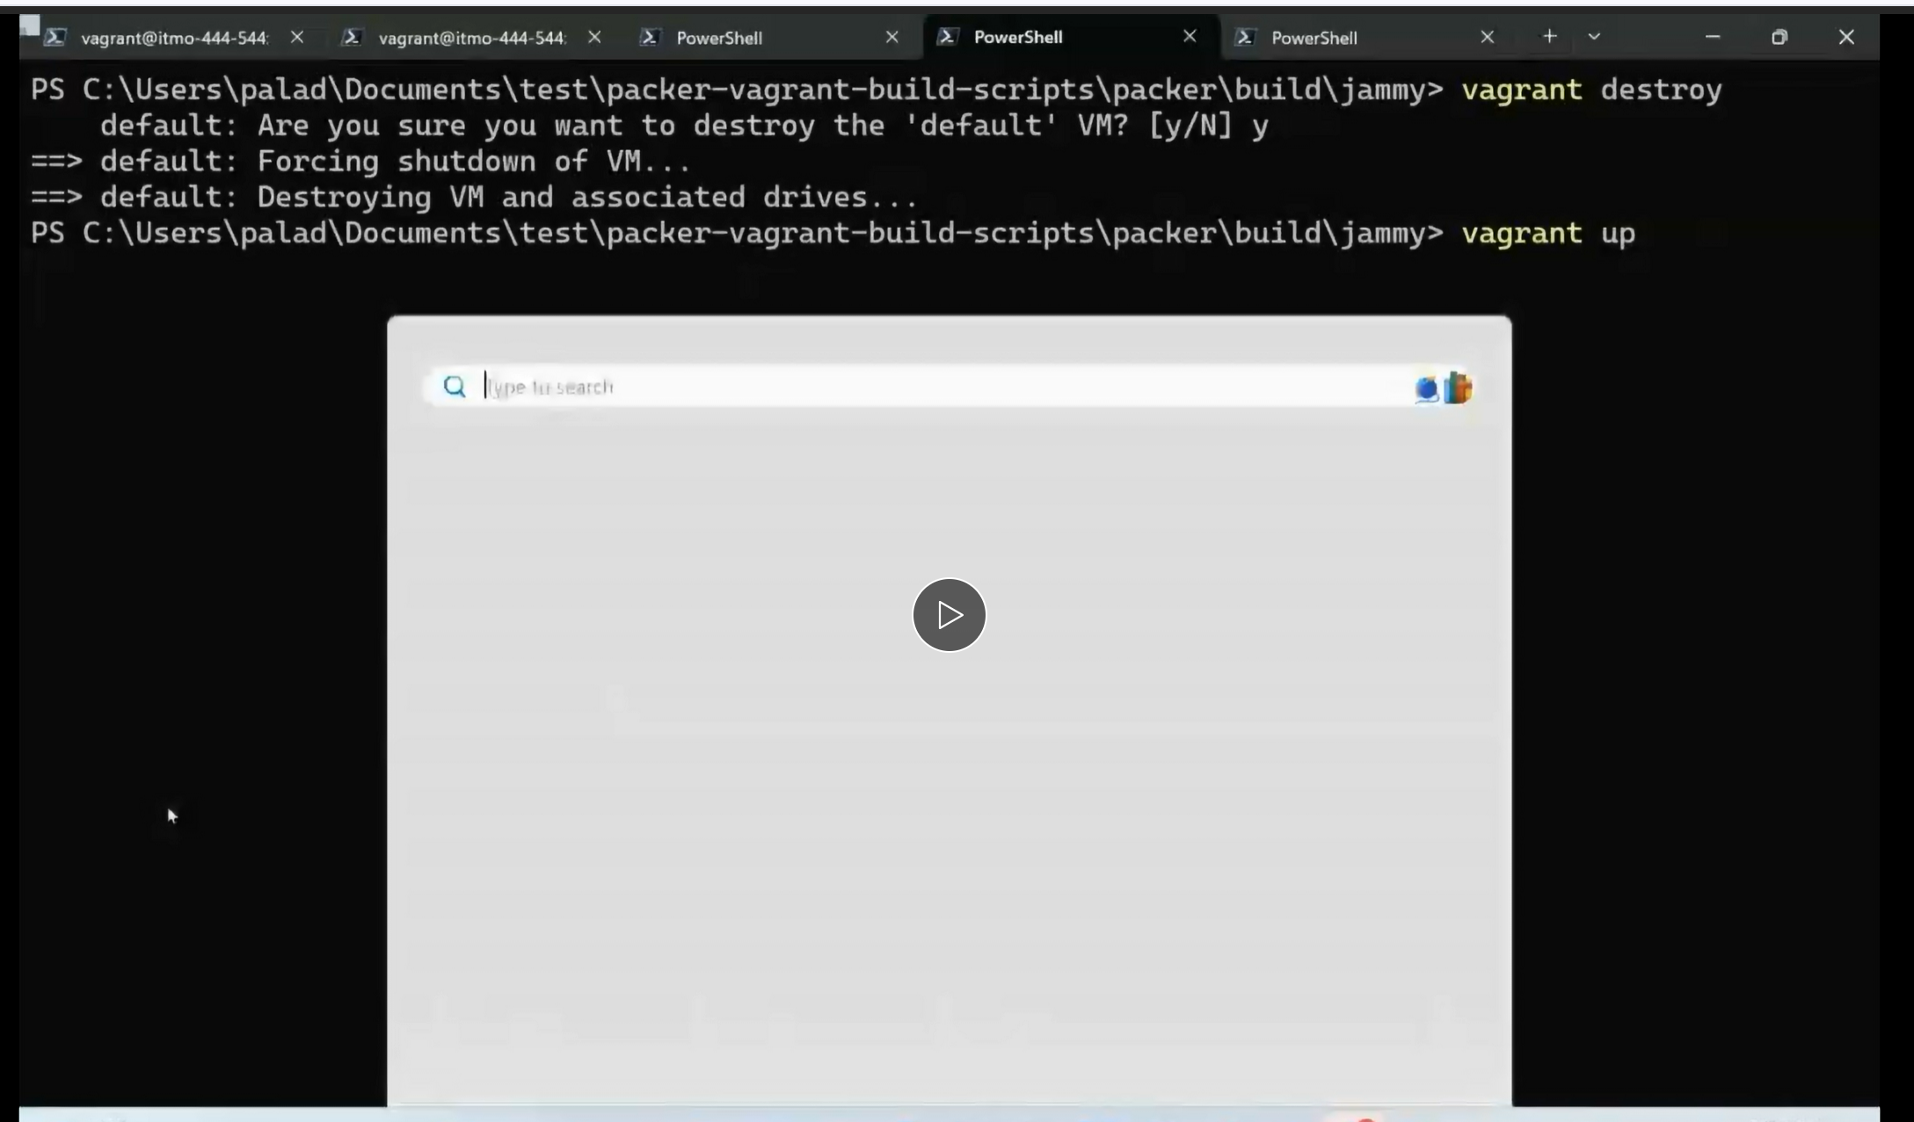

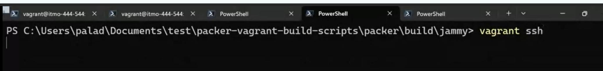

Now we do ls the homework folder is gone, nginx also not found after the destroy

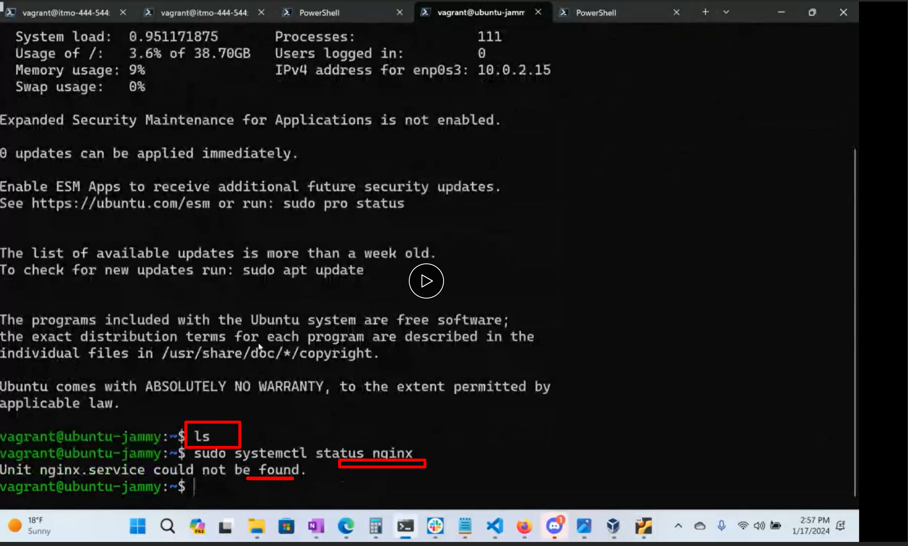

**Modify Settings in the Vagrantfile:**

Beautiful thing about virtualization is that it gives you virtual hard drives and we can attach multiple.

disks, also it gives your virtual networking.

The most imp thing is that From parallels or from virtual box you can set up **a host network :**is a

network where your host computer and the vm’s can talk to each other. So I can have 4/5 vm’s and

If you need to make a network on your laptop and you can enable host only network, it will

automatically assign them an ip address.

Use the host only network , you can communicate b/w all the systems

We can build an app on our lapotop

So HOW DO WE CHANGE THAT ?

Type **exit**

It will end ssh session but still you will be in jammy64

Do code vagrantfile….it will open up in vas code (jammy64 vagrant file)

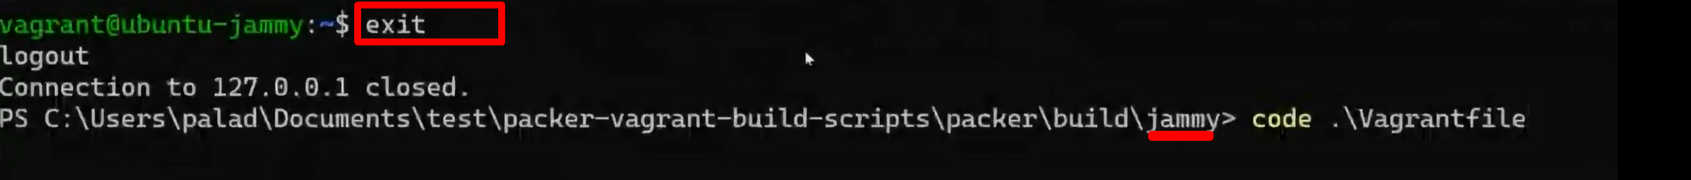

**Take a look at line 35** . it says config private network. **You need to uncomment it**

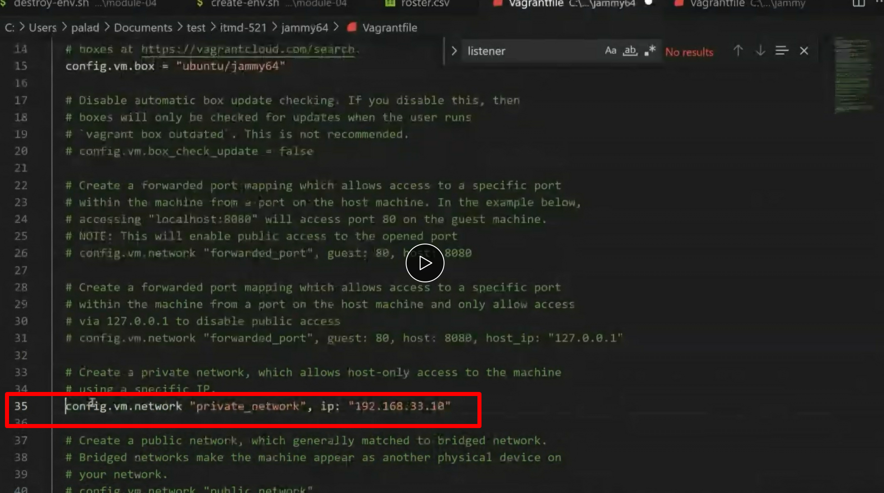

Now by default we will have **same ip address** for every host, but we **gotta change it**

**If its on linux it’s going to be .11**

It cant have the same ip address it can leads to collison**.**

*****prof said some thing here listen again and write here***50 min

**Also line 59 uncomment**

**64, 65 uncomment** this is how you enable more memory to the virtual machine

Increase memory to **4096** this mean 4 gigs (by default the memory is very conservative)

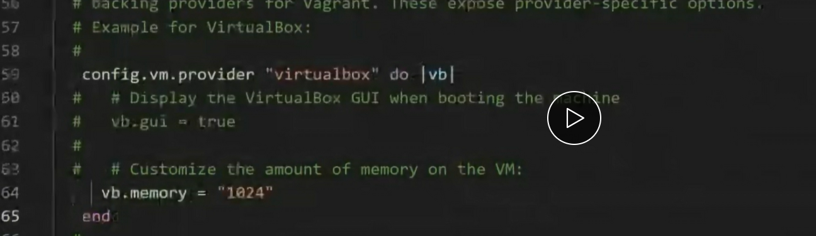

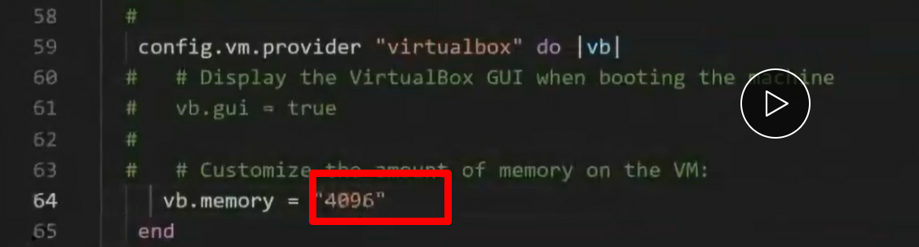

Save this file.(cntrl S)

Now to terminal type vagrant reload --provision

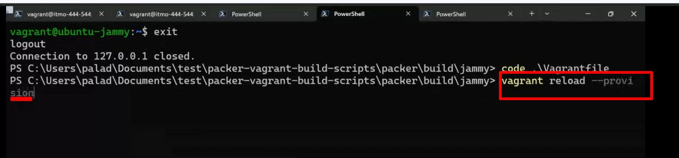

Whats this -- provision will do?

Hey, force the virtual box to re-read the vagrant file and make hardware changes.

If you don’t addd this –provision, it won’t examine the changes you just made in the vagrant file

Hit enter.

It will start rebooting

Shutting down

Prof got an error

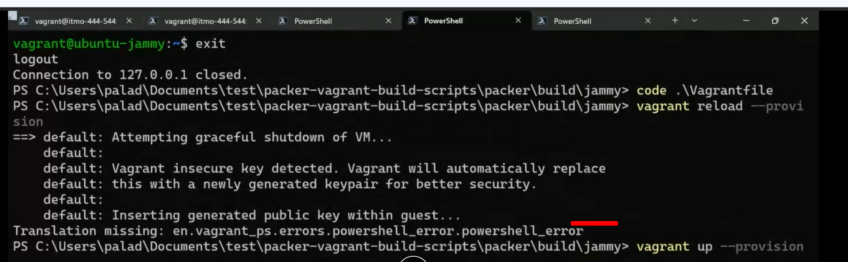

So what he did was:

vagrant up –provision

vagrant reload --provision

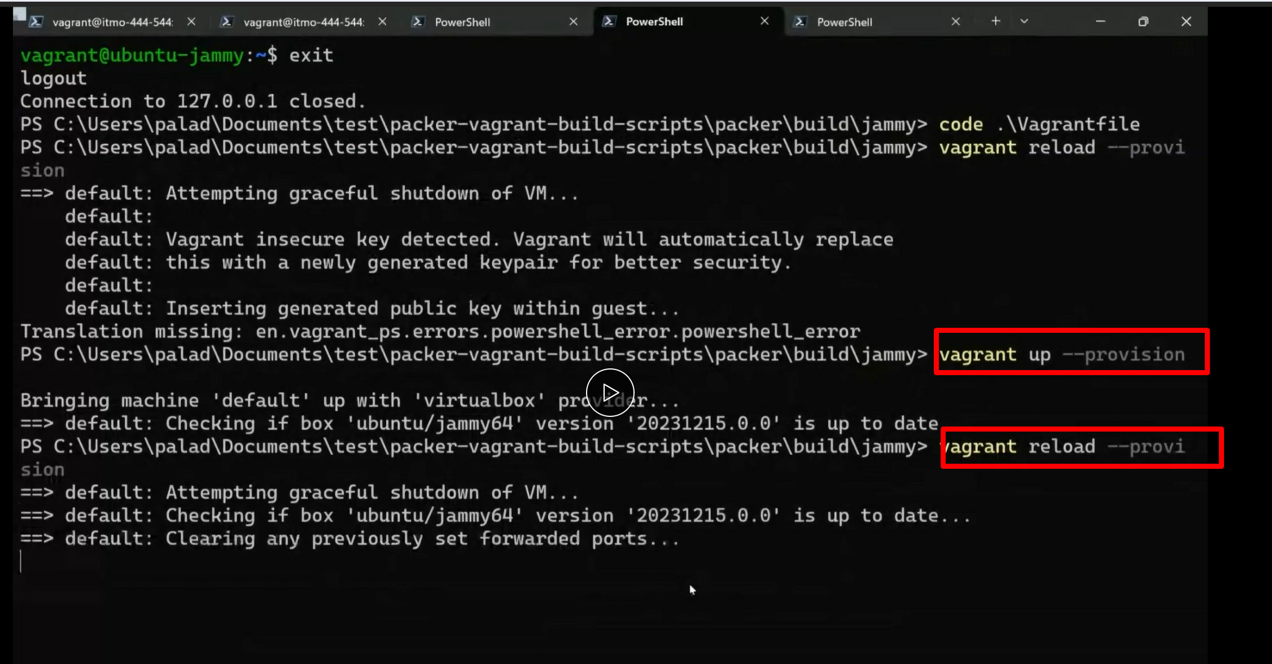

So its re starting now, re booting

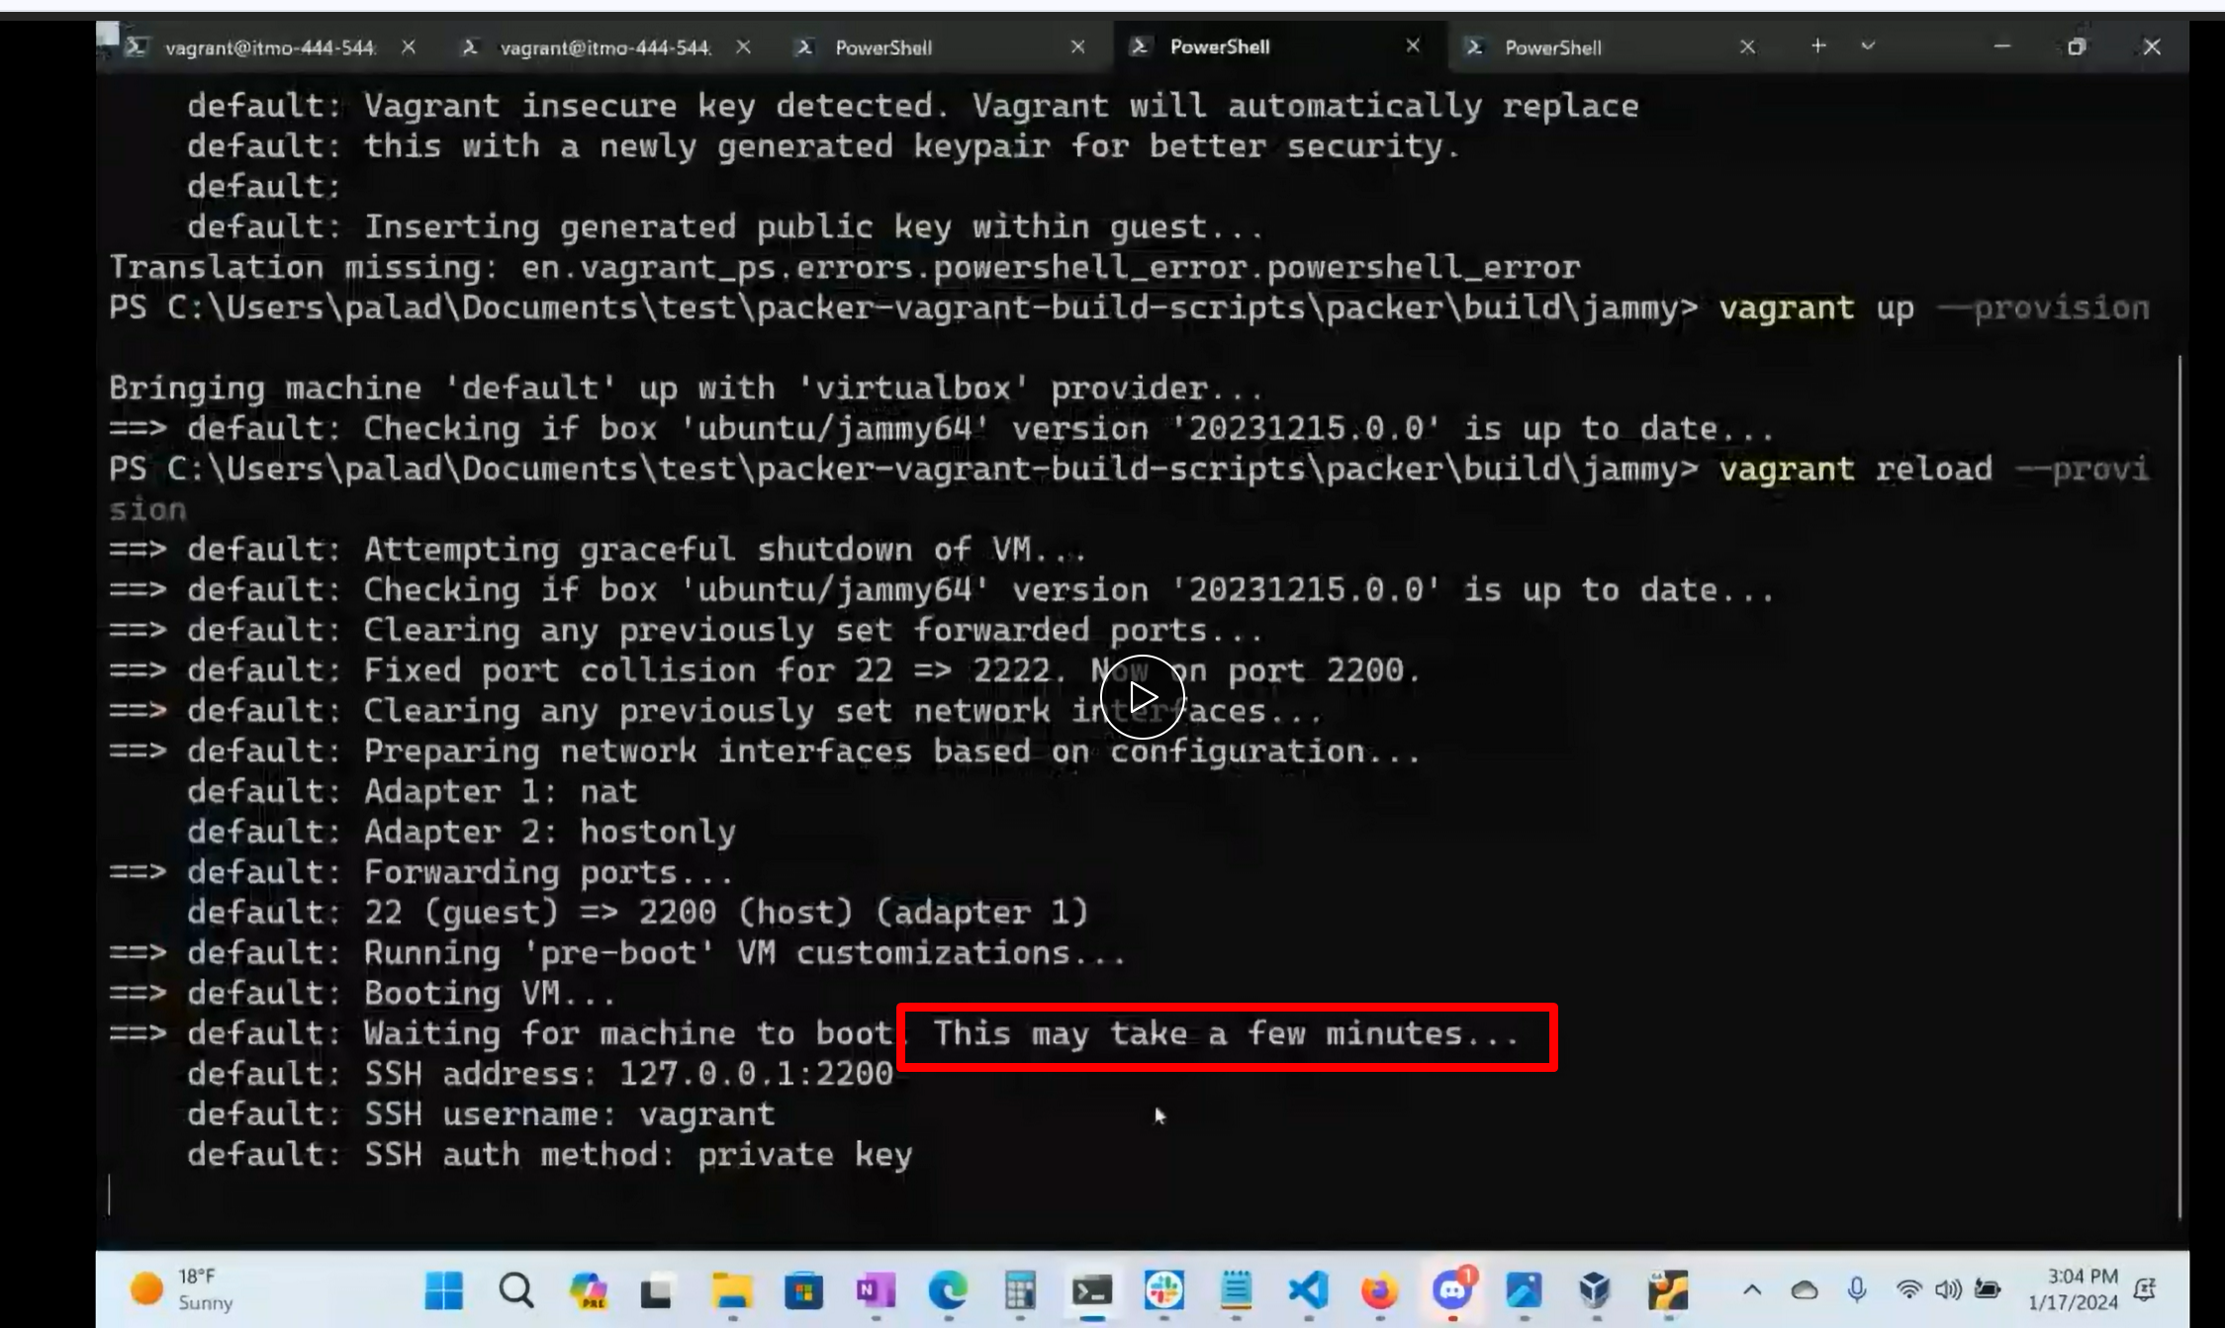

**ON WINDOWS If its 1st time enabling host only interface we will get prompted like oracle pop up like:**

**Hey oracle wants to add another driver for virtual box ………..say yes**

Next

We may get this long install too after you have done destroy or the 1st time

Its going to get the dependencies for the oracle vb guest editions, for additional drivers that allow like

For integration in virtualized os

it only happens if 1st time or after you destroy **video 54 min**

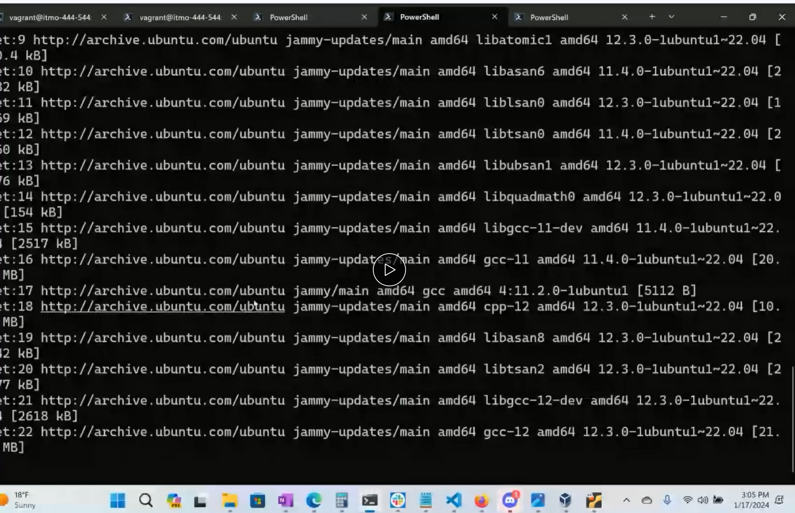

**Now run these commands**



**Now install nginx:**

If we are using almalinux change apt to dnf

If its jammy64, you can use sudo apt

Nginx is a webserver.

Once its installed take that ip address.. open up browswe and see the hello world

You will be serving from an ubuntu Newtok on host only network , you will be serving web pages on your

own system

**here still in prev step config network interfaces,, not nginx****

you will see this output

we will get to see 2 network interfaces

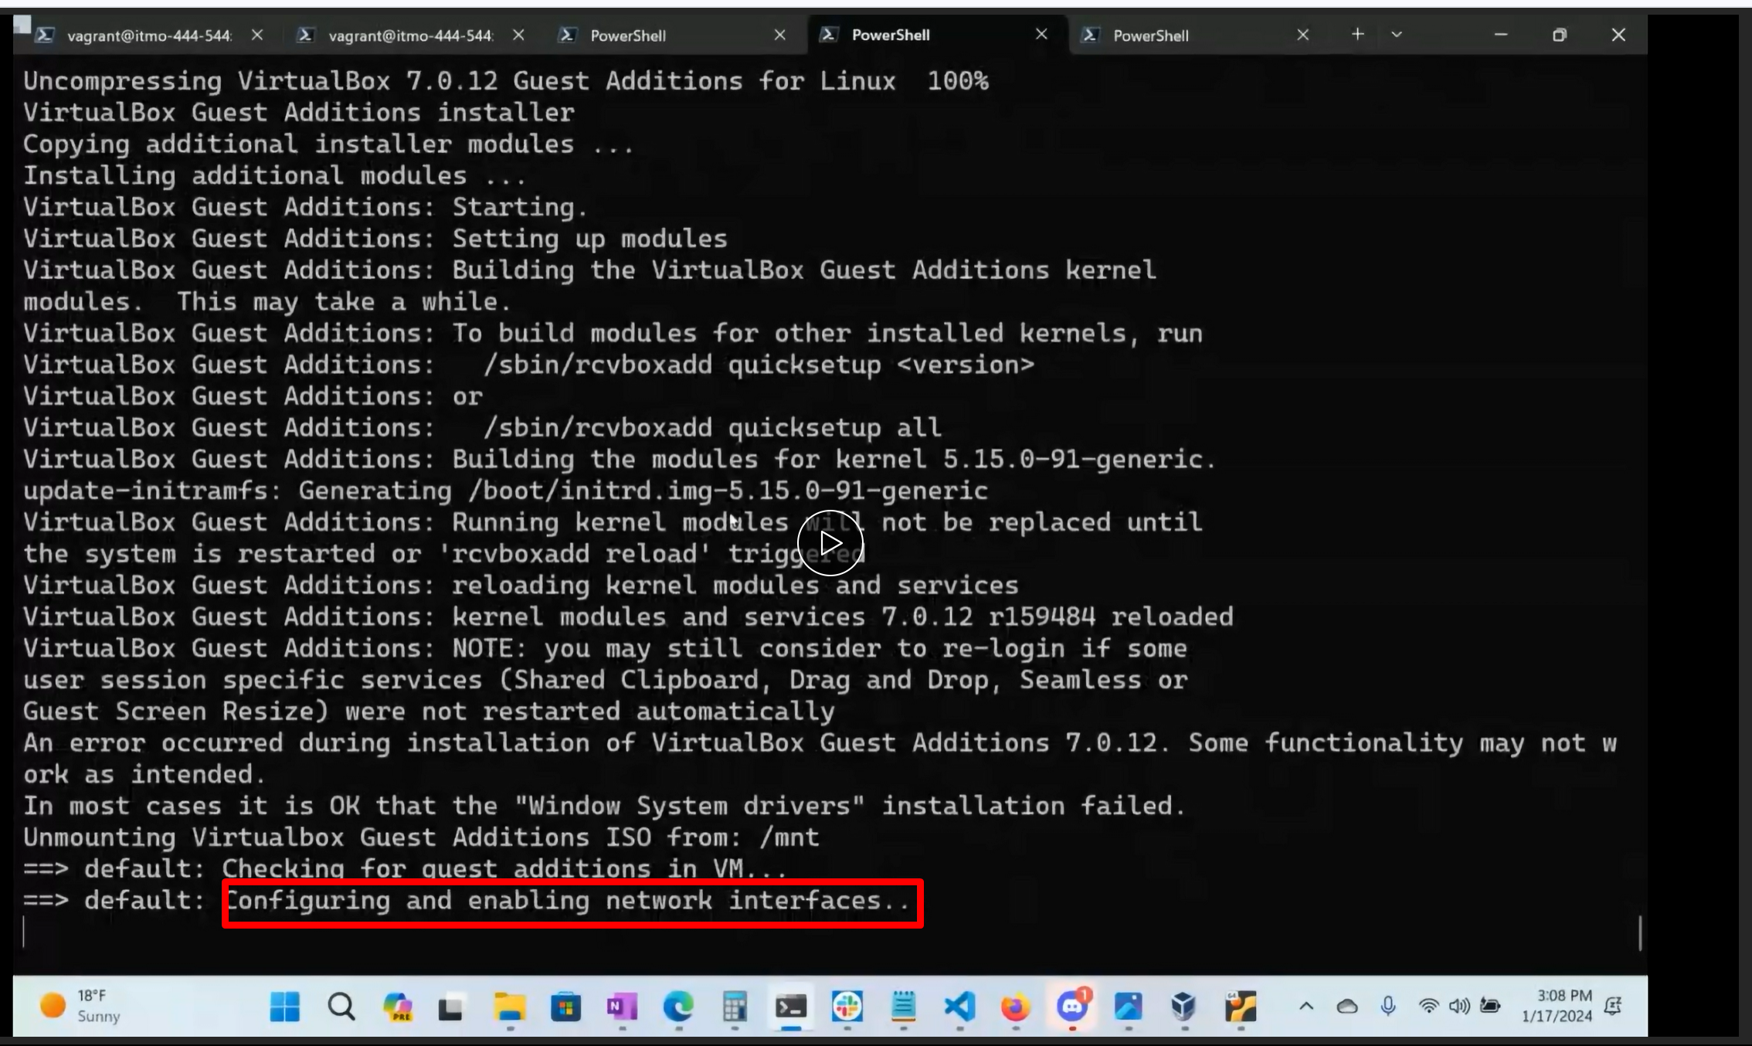

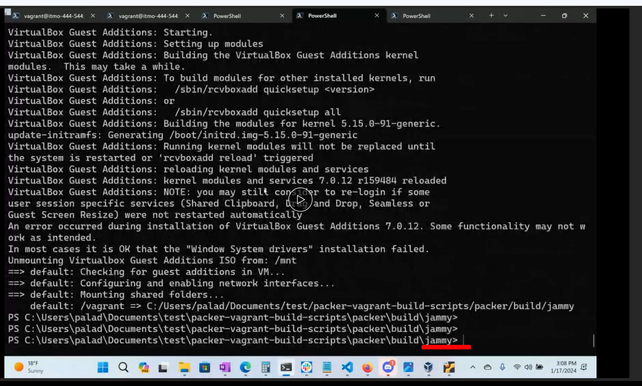

So now connect to virtual machine

Command ?

vagrant ssh -

we will see an ip address here, this is our host only address(our might be different) keept it default

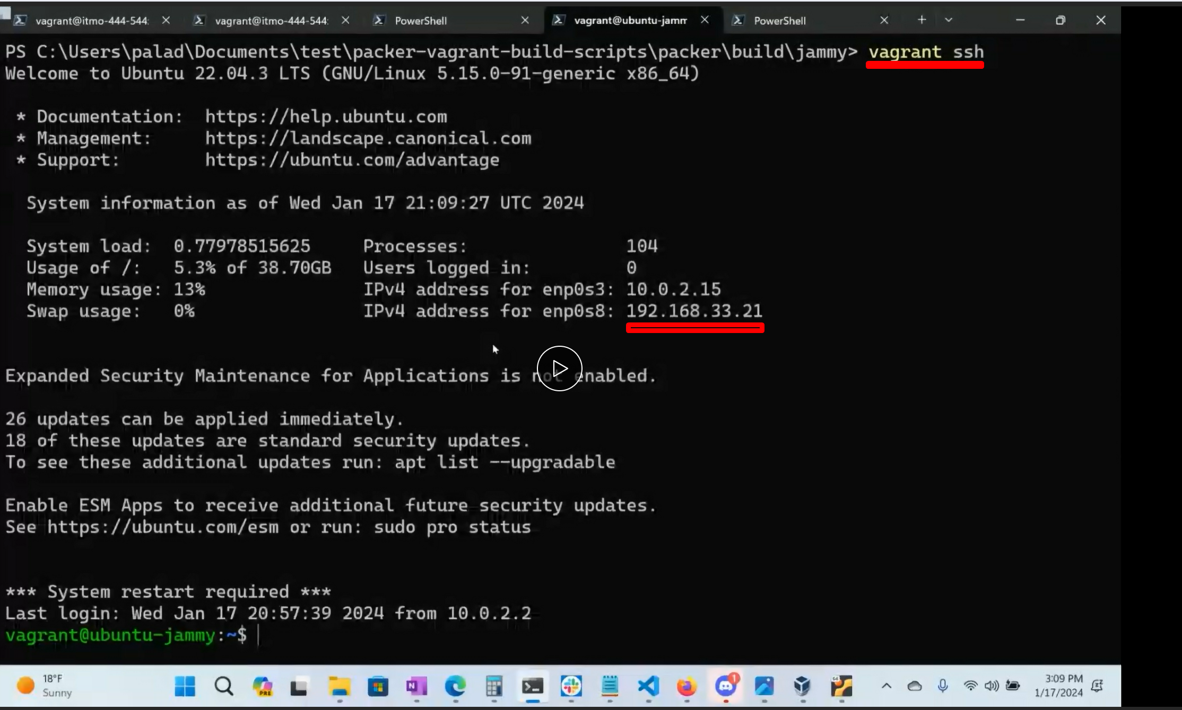

Then do

**sudo apt update**

The 1st thing you do is check for updates

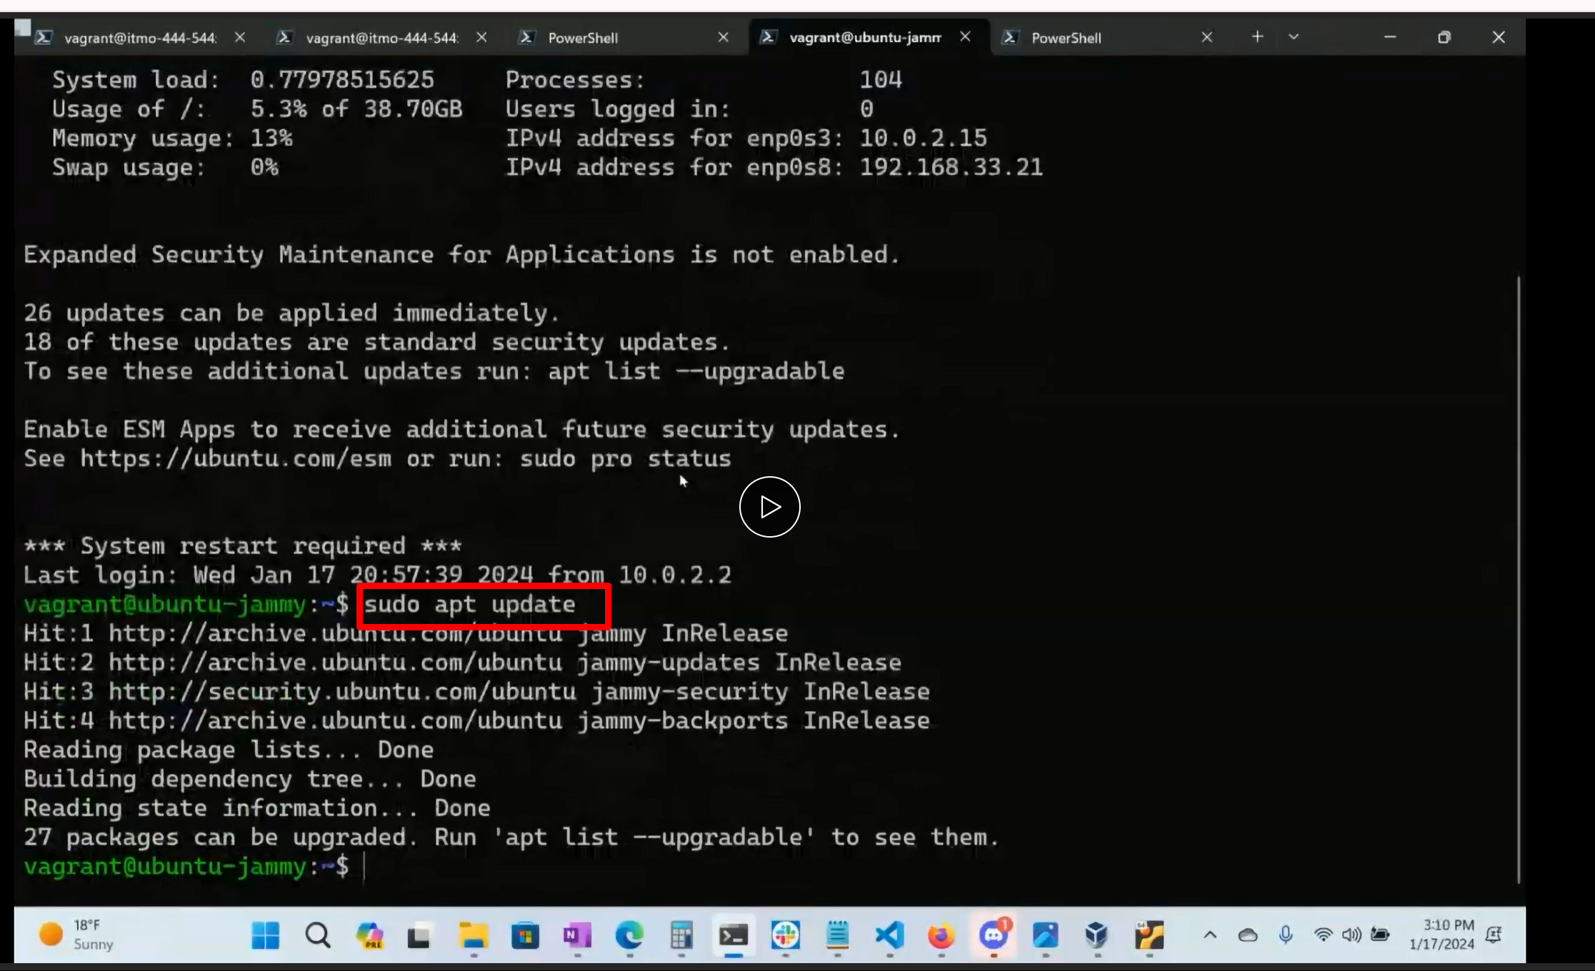

**Install nginx**

**Sudo apt install nginx**

Hit enter.. its gonna say these are all the packages and dependencies to install

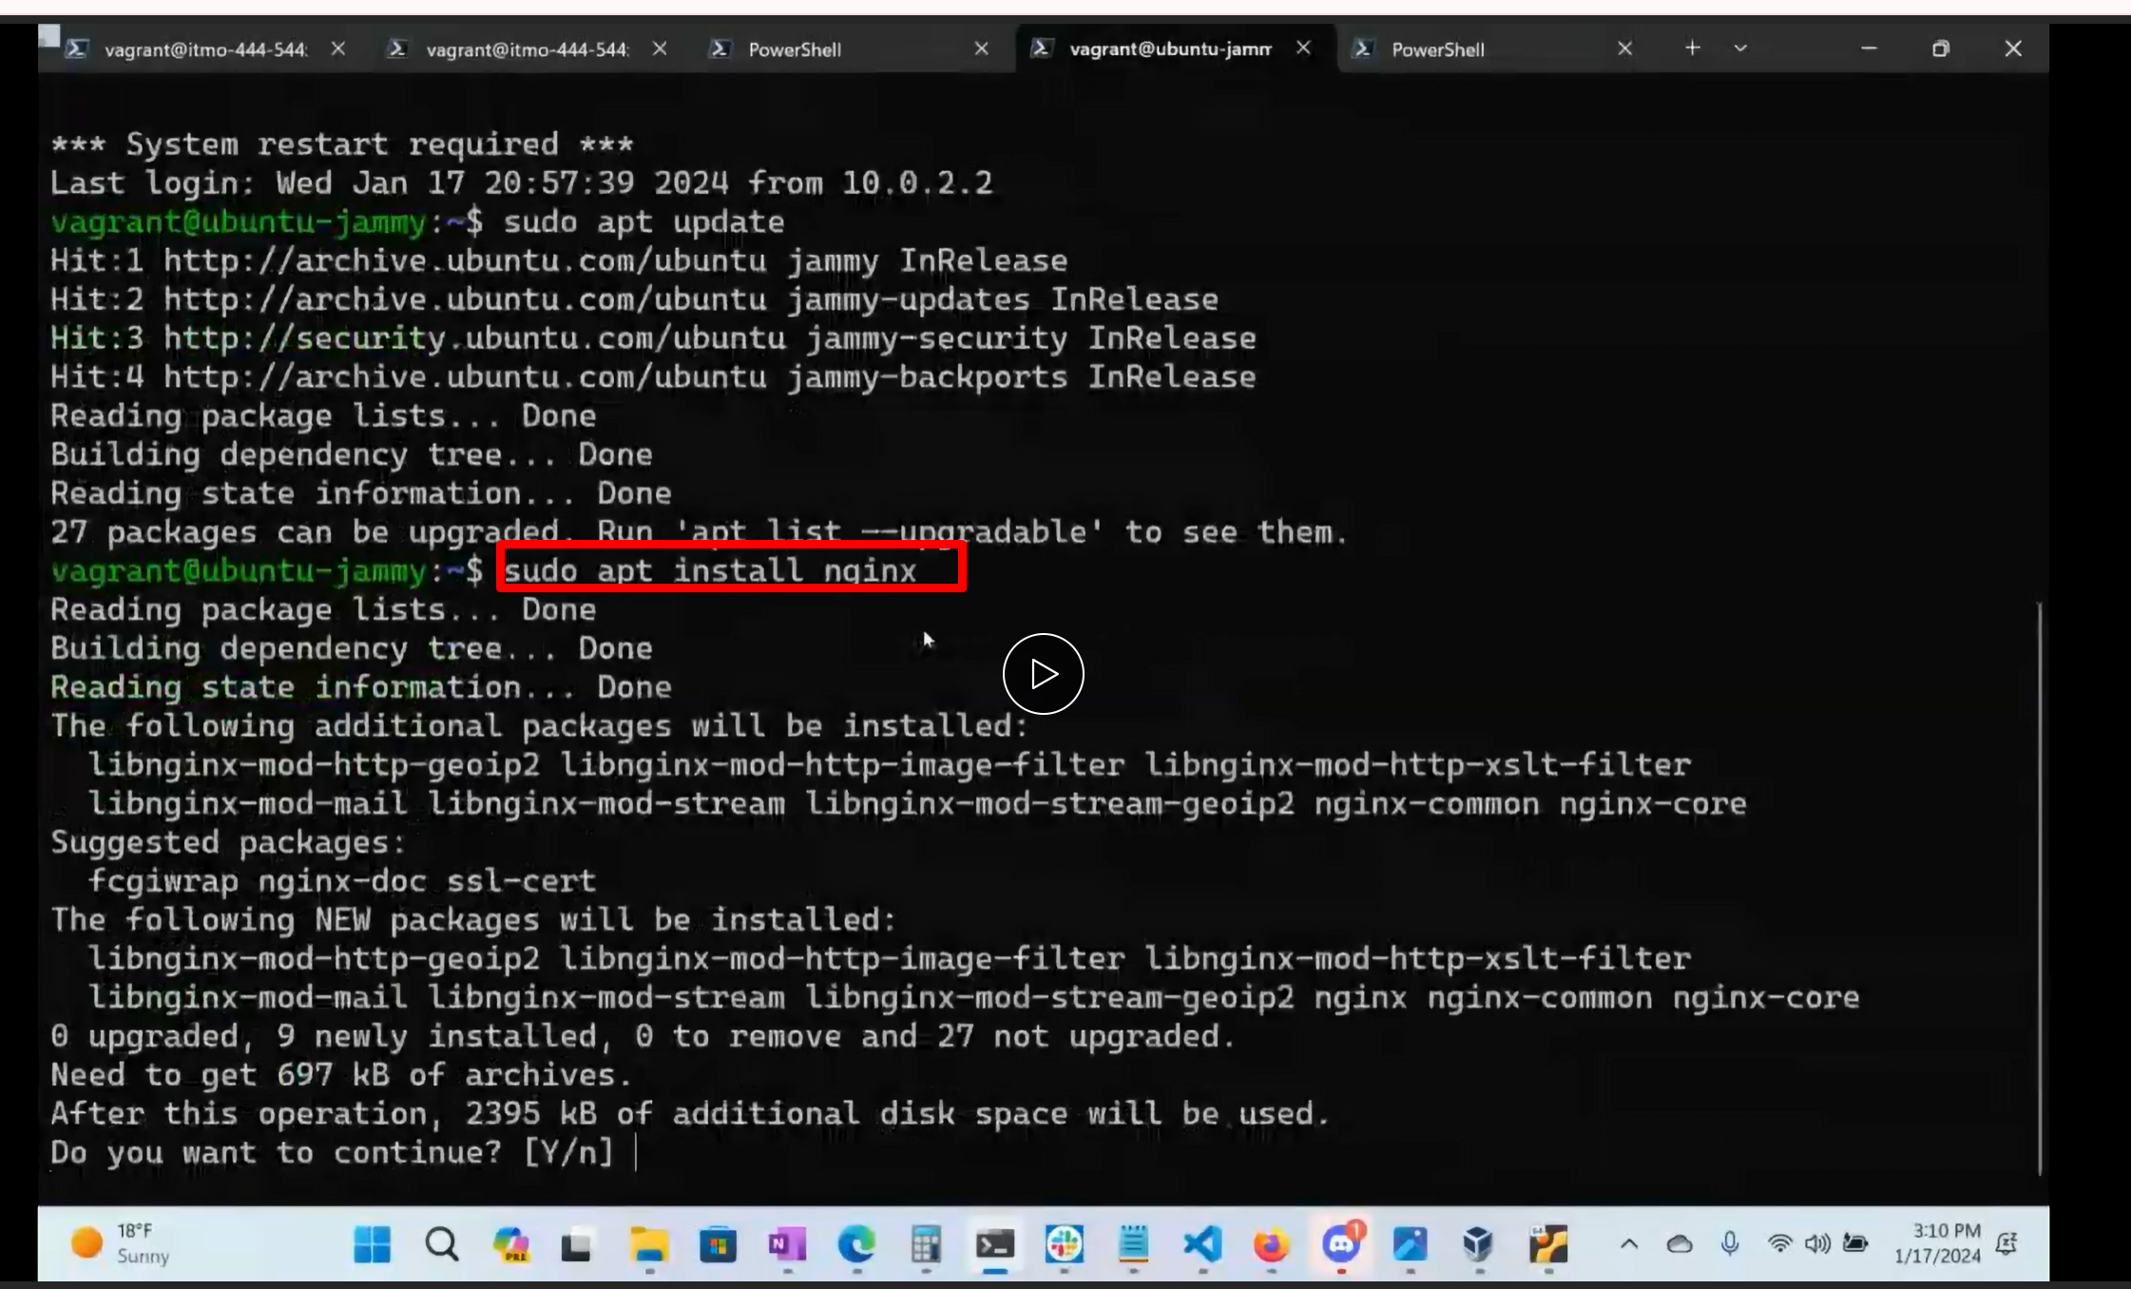

It s gonna sk you… say y

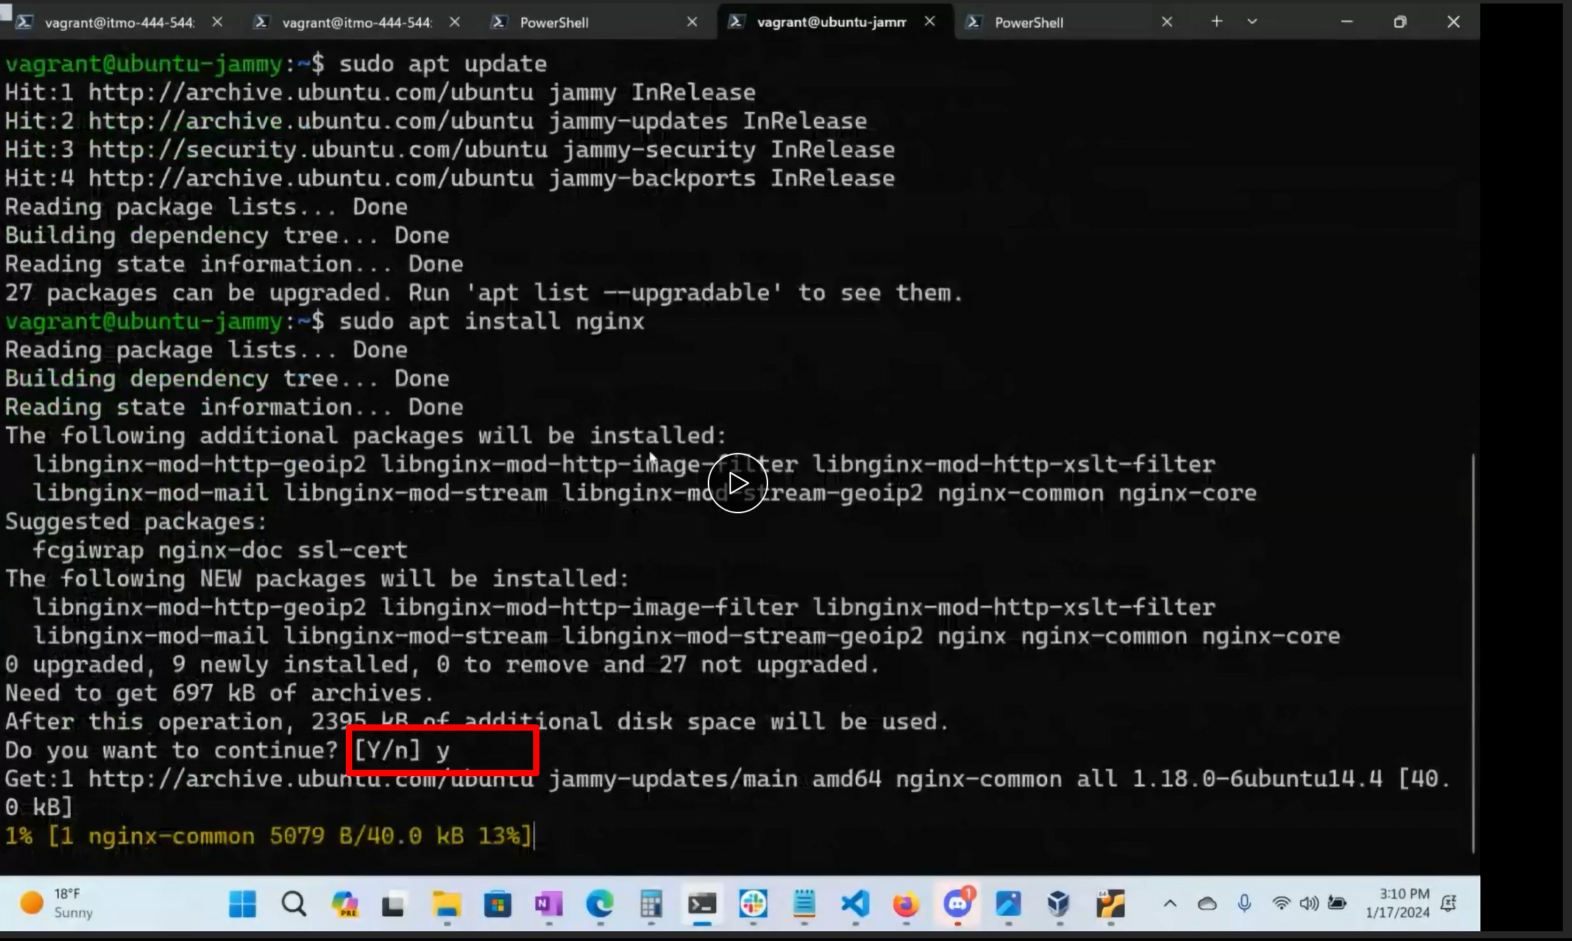

You wll see this pop up ..press tab key and select ok (this is basically asking us “hey im gonna restart all

The services,,is there anything you don’t want me to restart? (at this point we just say ,,whatever just do

it

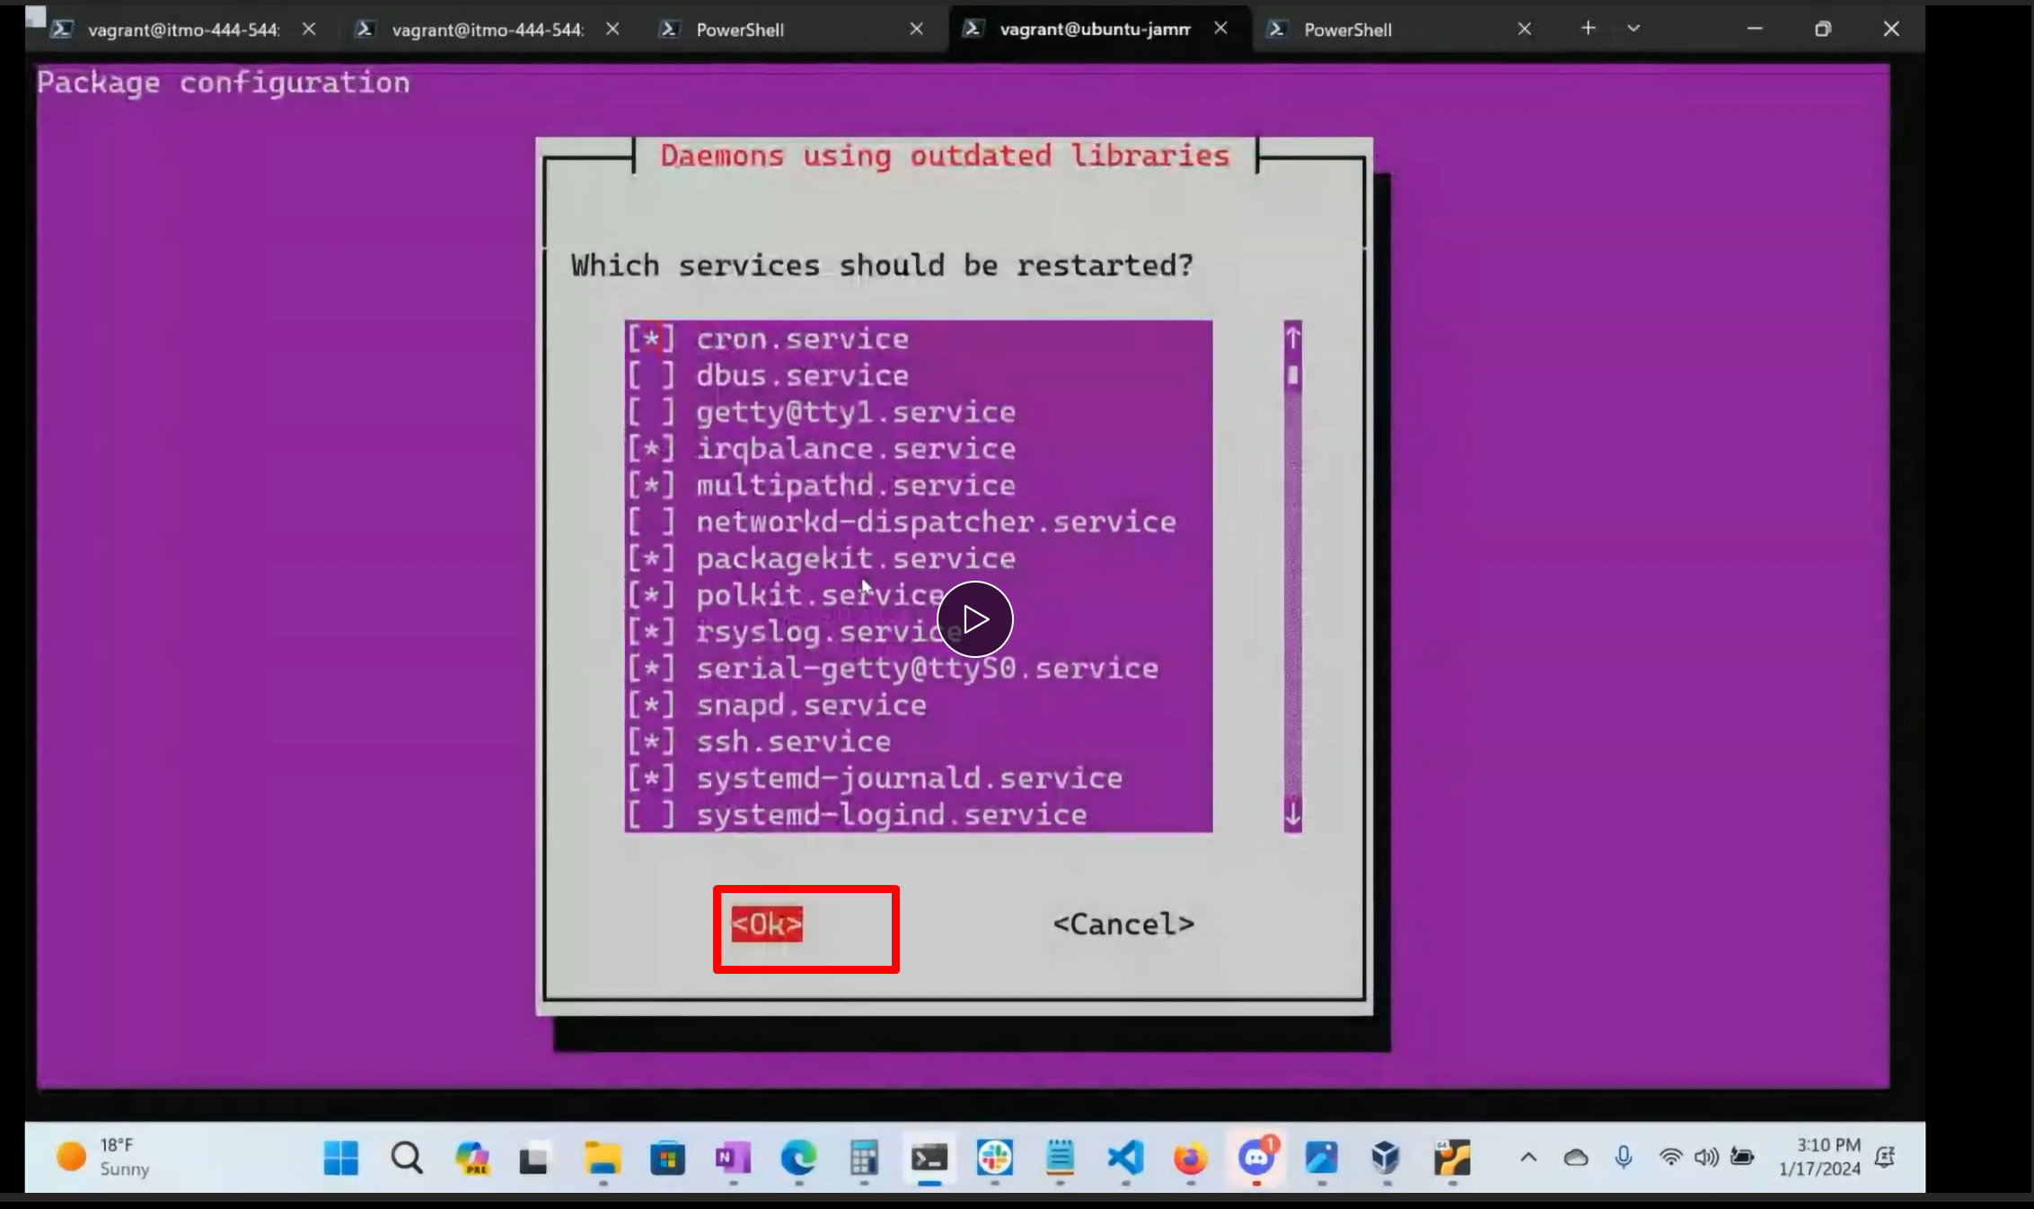

We connected

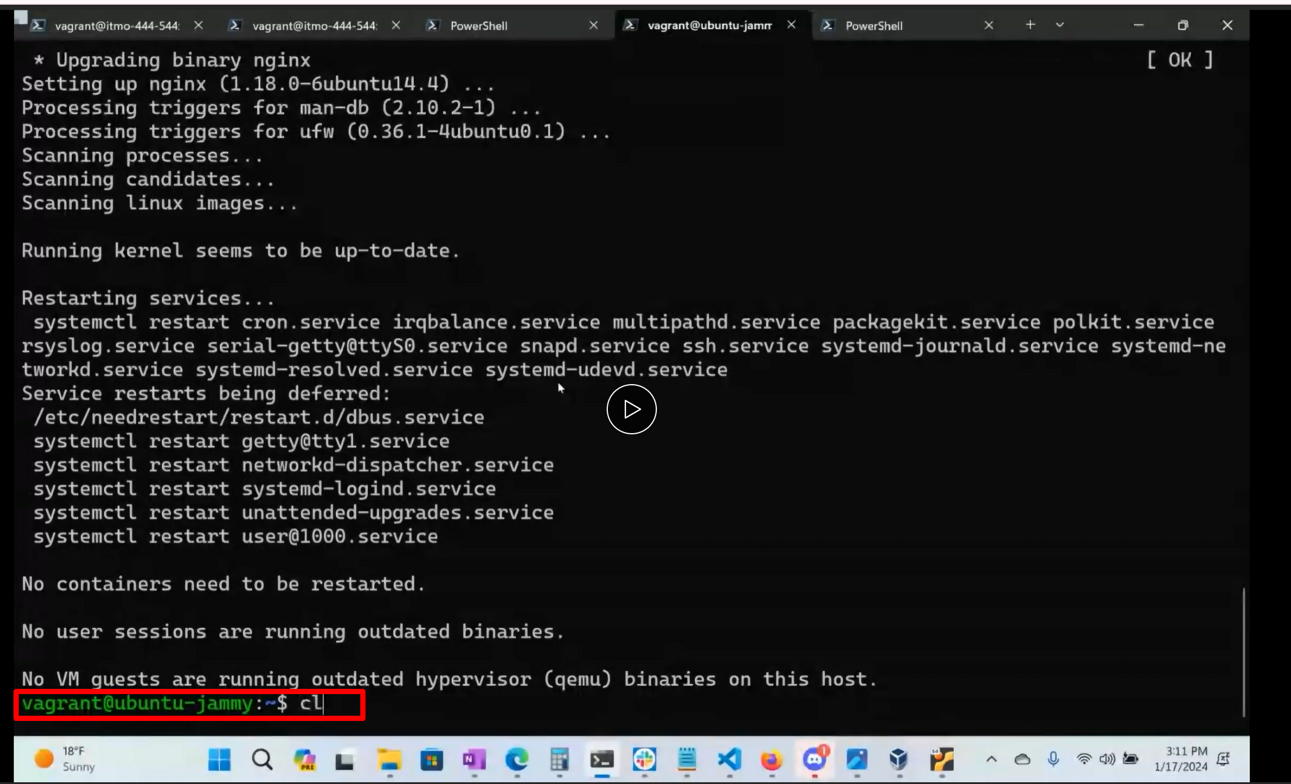

Type clear and the next command is

**sudo systemctl enable --now nginx**

this will start the service an dit will make it start eveytime when the system reloads automatically. So we

run this just to make sure

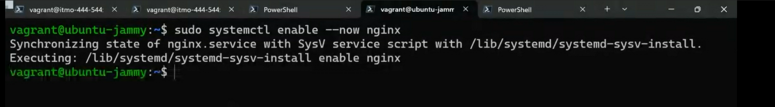

And the last thing we can do is

**sudo systemctl status nginx**

we will get a running msg like this I its running……see its active running (green)

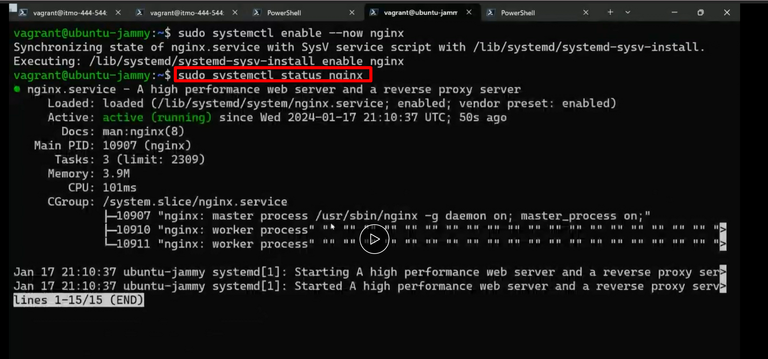

If im not sure what my ip address was:

**ip a sh (ip address show)**

we will look for enp for intel mac, virtual box (if its parellels pro, it is different)

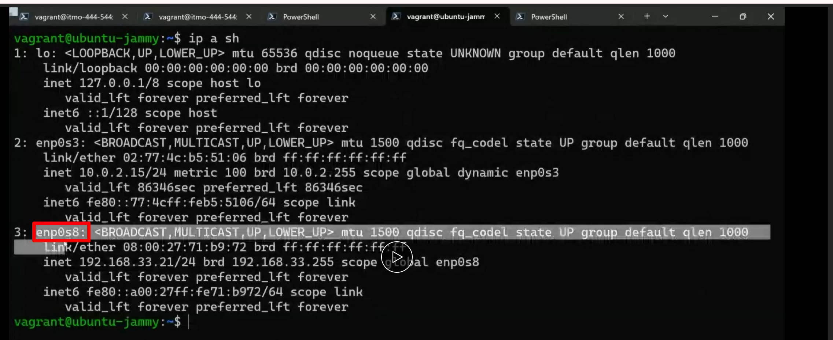

Copy this

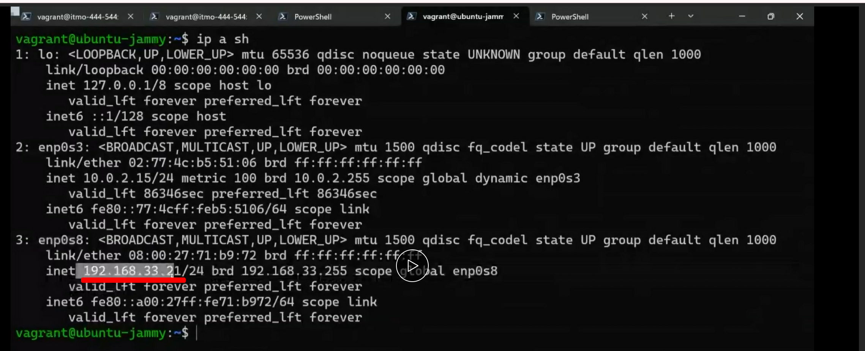

Open a browser in our local system and paste this with **http**

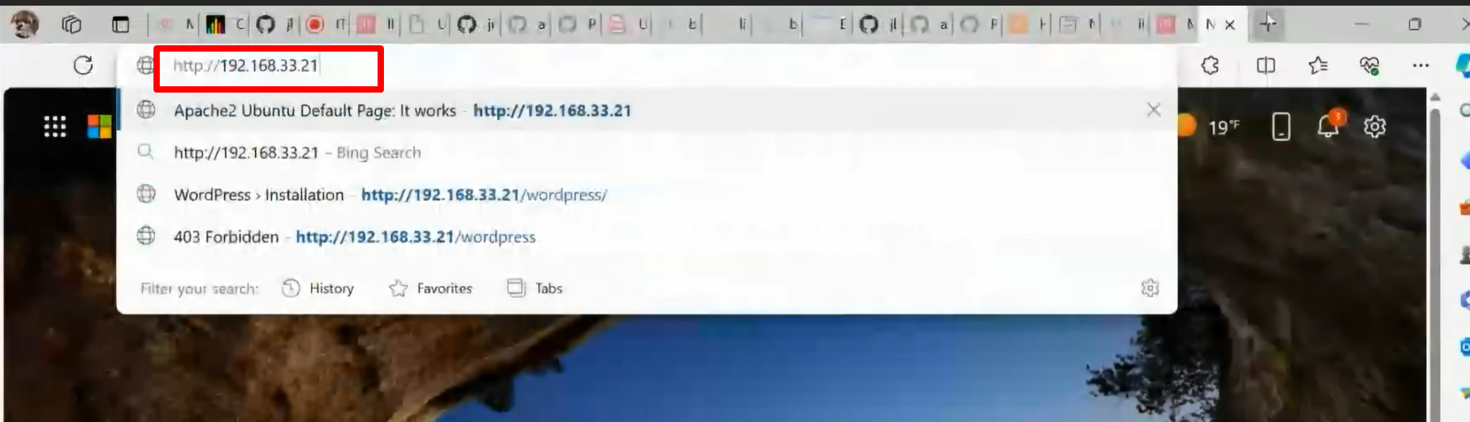

BOOM ..we got a server

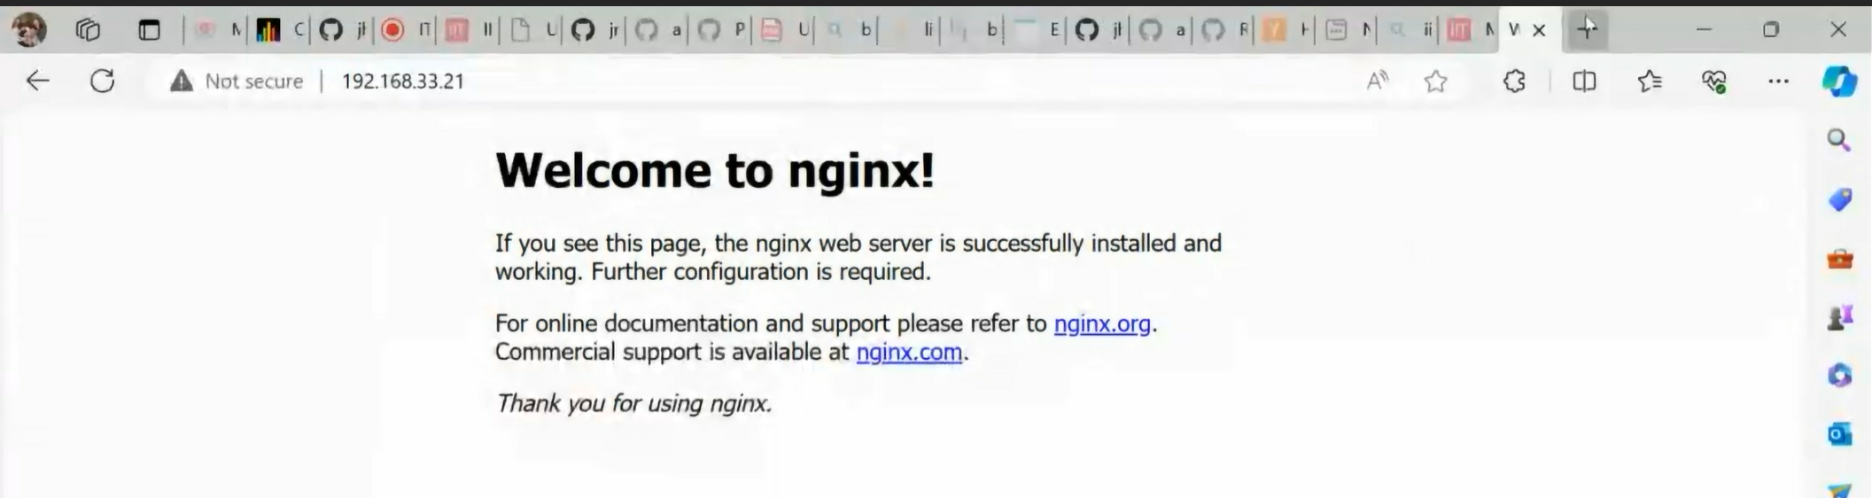

**INSIDE VAGRANT BOX STEPS**:

Section 1,2,3 video 55 min

Change hostname to our initials and course number:

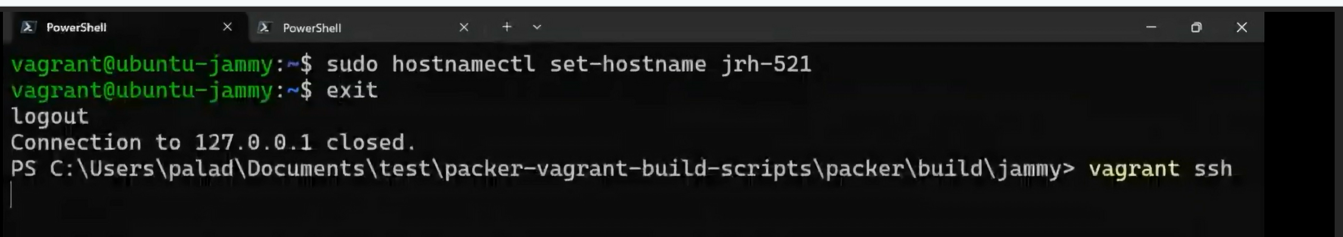

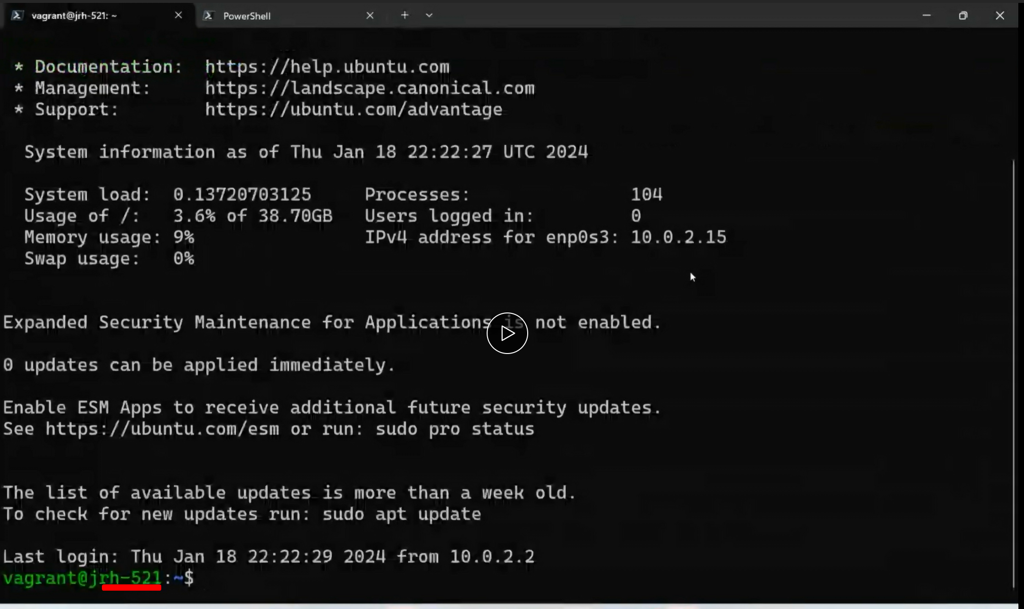

Screenshot this one after typing clear

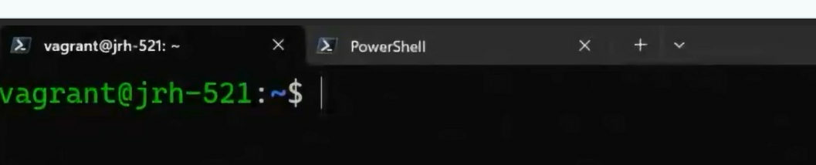

2. add these values to bashrc: we can do code

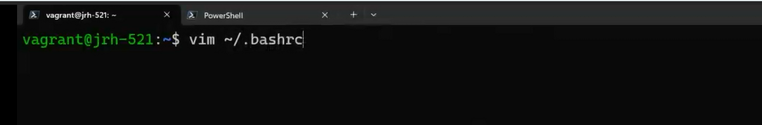

3. 